EXPLORING THE IMPACT OF IT GOVERNANCE MECHANISMS ON IT AGILITY CAPABILITIES AND CONSEQUENCES OF CENTRALIZATION OF IT GOVERNANCE

A THESIS SUBMITTED TO
THE GRADUATE SCHOOL OF INFORMATICS OF
THE MIDDLE EAST TECHNICAL UNIVERSITY
BY

BURÇİN SARI

IN PARTIAL FULFILLMENT OF THE REQUIREMENTS FOR THE DEGREE OF DOCTOR OF PHILOSOPHY
IN
THE DEPARTMENT OF INFORMATION SYSTEMS

MAY 2024

Approval of the thesis:

EXPLORING THE IMPACT OF IT GOVERNANCE MECHANISMS ON IT AGILITY CAPABILITIES AND CONSEQUENCES OF CENTRALIZATION OF IT GOVERNANCE

Submitted by BURÇİN SARI in partial fulfillment of the requirements for the degree of Doctor of Philosophy in Information Systems Department, Middle East Technical University by,

Prof. Dr. Banu GÜNEL KILIÇ
Dean, Graduate School of Informatics

Prof. Dr. Altan KOÇYİĞİT
Head of Department, Information Systems

Prof. Dr. Sevgi Özkan Yıldırım
Supervisor, Information Systems, METU

Prof. Dr. Munir Mandviwalla
Co-Supervisor, Fox School of Business, Temple University

Examining Committee Members:

Prof. Dr. Mehmet Abdülkadir Varoğlu
Dept. of Business Administration, Başkent University

Prof. Dr. Sevgi Özkan Yıldırım
Information Systems Dept., METU

Prof. Dr. Dilek Başar
Dept. of Economics, Hacettepe University

Prof. Dr. Pekin Erhan Eren
Information Systems Dept., METU

Prof. Dr. Altan KOÇYİĞİT
Information Systems Dept., METU

Date: 22.05.2024

I hereby declare that all information in this document has been obtained and presented in accordance with academic rules and ethical conduct. I also declare that, as required by these rules and conduct, I have fully cited and referenced all material and results that are not original to this work.

Name, Last name : Burçin Sarı

Signature :

ABSTRACT

EXPLORING THE IMPACT OF IT GOVERNANCE MECHANISMS ON IT AGILITY CAPABILITIES AND CONSEQUENCES OF CENTRALIZATION OF IT GOVERNANCE

Sarı, Burçin
Ph.D., Department of Information Systems
Supervisor: Prof. Dr. Sevgi Özkan Yıldırım
Co-Advisor: Prof. Dr. Munir Y. Mandviwalla

May 2024, 110 pages

As information technology (IT) budgets continue to rise and IT’s centrality in businesses grows, effective IT governance (ITG) has become crucial for organizations aiming to swiftly respond to environmental shifts and seize emerging opportunities. This study investigated the relationship between ITG mechanisms (ITGMs), particularly relational aspects, and organizational agility. Employing a combined approach, first, the literature on ITG was reviewed, emphasizing relational mechanisms, processes, and structures. Subsequently, a focus group study was performed with 7 professionals who have 20+ years’ experience in IT to delve into how ITG influences IT agility (ITA) in the context of market dynamics. Building on these insights, a survey was conducted to explore the impact of ITG on ITA further by collecting data from 225 companies that operate in Türkiye and the USA. The findings showed the significance of relational ITGMs in enhancing ITA, highlighting its pivotal role in responding to business environmental changes.
Moreover, as organizations expand, centralizing ITG emerges as a strategy to enhance the effectiveness and efficiency of business processes. However, the efficacy of this approach remains uncertain. This was addressed by conducting semi-structured interviews with 11 senior experts in a large technology organization. The analysis suggested that rigid adherence to complete centralization or decentralization proves suboptimal. Instead, a hybrid approach, which is combining high-level centralization with tailored options for business units, emerged as a more acceptable solution.

Keywords: IT Governance Mechanisms, IT Agility, Centralization of IT Governance

ÖZ

BT YÖNETİŞİM MEKANİZMALARININ BT ÇEVİKLİK YETENEKLERİ ÜZERİNDEKİ ETKİSİNİN KEŞFEDİLMESİ VE BT YÖNETİŞİMİNİN MERKEZİLEŞMESİNİN ETKİLERİ

Sarı, Burçin
Doktora, Bilişim Sistemleri Bölümü
Tez Yöneticisi: Prof. Dr. Sevgi Özkan Yıldırım

Mayıs 2024, 110 sayfa

Bilgi Teknolojisi (BT) bütçeleri artmaya devam ettikçe ve BT'nin işletmelerdeki merkeziliği arttıkça; etkili BT yönetişimi, çevresel değişimlere hızlı bir şekilde yanıt vermeyi ve ortaya çıkan fırsatları yakalamayı amaçlayan kuruluşlar için hayati önem taşıyor. Bu tez, BT yönetişim mekanizmalarının kurumsal ve BT çevikliği arasındaki ilişkiyi araştırmaktadır. Öncelikle ilişkisel mekanizmaları, süreçleri ve yapıları vurgulayarak BT yönetişimine ilişkin literatürü inceledik. Ardından, BT yönetişiminin pazar dinamikleri bağlamında BT çevikliğini nasıl etkilediğini araştırmak için BT alanında 20 yıldan fazla deneyime sahip 7 profesyonelle bir odak grup çalışması yürüttük. Bu öngörülerden yola çıkarak, Türkiye ve ABD'de faaliyet gösteren 225 şirketten veri toplayarak BT yönetişiminin BT çevikliği üzerindeki etkisini araştırmak amacıyla bir anket yürüttük. Sonuçlarımız, ilişkisel BT yönetişim mekanizmalarının BT çevikliğini artırmadaki ve iş ortamındaki değişikliklere yanıt vermedeki önemli rolünü vurgulamaktadır.
Bununla birlikte, şirketler büyüdükçe BT yönetişiminin merkezileştirilmesi, iş süreçlerinin etkililiğini ve verimliliğini artırmaya yönelik bir strateji olarak ortaya çıkmaktadır. Ancak, bu yaklaşımın etkinliği belirsizliğini korumaktadır. Bu konuyu büyük bir teknoloji şirketindeki 11 kıdemli uzmanla yarı yapılandırılmış görüşmeler yaparak ele aldık. Analizimiz sonucunda, tam merkezileşme veya merkezi olmayan yönetişim yerine, üst düzey merkezileştirmeyi iş birimlerine özel seçeneklerle birleştiren hibrit bir yaklaşım daha kabul edilebilir bir çözüm olduğu değerlendirilmiştir.
Anahtar Sözcükler: BT Yönetişim Mekanizmaları, BT Çevikliği, Merkezi BT Yönetişimi

DEDICATION

To My Lovely Daughter, Buse

ACKNOWLEDGMENTS

I extend my heartfelt appreciation to my supervisor, Prof. Dr. Sevgi Özkan Yıldırım, and my co-advisor, Prof. Dr. Munir Mandviwalla, for their continuous support and encouragement throughout my academic journey.
I am grateful to my examining committee members, Prof. Dr. Dilek Başar and Prof. Dr. Erhan Eren, for their valuable contributions to my research.
I express my deepest gratitude to my mother, husband, and family for their patience and continuous support during the writing of my thesis. Additionally, I consider myself fortunate to have a beautiful and smart daughter, Buse who entered my life during my PhD studies, bringing strength and joy to my world.
Lastly, I dedicate my thesis, presented in memory of my beloved father, who passed away during the course of its completion, and whose pride I believe would have been immeasurable had he witnessed its finalization.

TABLE OF CONTENTS

ABSTRACT iv
ÖZ vi
DEDICATION viii
ACKNOWLEDGMENTS ix
TABLE OF CONTENTS x
LIST OF TABLES xii
LIST OF FIGURES xiv
LIST OF ABBREVIATIONS xv
CHAPTERS
1. INTRODUCTION 1
1.1. Problem Statement 3
1.2. Research Questions 4
1.3. Purpose of the Study 5
1.4 Significance of the Study 6
1.5 Research Methodology 7
1.6 Outline of the document 9
2. LITERATURE REVIEW 11
2.1.1 ITG Structures 19
2.1.2 ITG Processes 20
2.1.3 Relational Mechanisms 21
2.1.4 ITA 22
2.1.5 Centralization of ITG 24
3. HYPOTHESES DEVELOPMENT AND CONCEPTUAL MODEL 27
3.1 Phase 1: Qualitative Analysis: Focus Group Study 32
3.2 Phase 2: Quantitative Analysis: Survey 38
3.2.1 Instrument Development 38
3.2.2 Dataset 41
3.3 Semi-Structured Interviews About the Centralization of ITG 44_Toc171089481
4. DATA ANALYSIS AND RESULTS 47
4.1. Preliminary Analysis 47
4.2. Covariance Structural Equation Modeling (CB-SEM) 53
4.2.1. Measurement Model 54
4.2.2. Reliability and Validity of the Model and Model Fit 54
4.2.3. Structural Model and Hypotheses Testing 60
4.3. Partial Least Squares Structural Equation Modeling (PLS-SEM) 63
4.3.1. Confirmatory Factor Analysis (CFA) 63
4.3.2. Hypotheses Testing 66
4.3.2.1. Hypothesis Testing with Control Variables 68
4.3.2.2. Hypotheses Testing with Location as a Moderator Variable 70
4.4. Second Round of Focus Group Study 71
4.5. Results of the Semi-Structured Interviews Regarding the Centralization of ITG …. 73
5. DISCUSSION AND CONCLUSION 81
REFERENCES 89
APPENDICES 97
APPENDIX A 97
APPENDIX B 99
2. IT Governance Structure: 99
3. IT Governance Process: 101
4. Relational Mechanisms: 103
APPENDIX C 105
CURRICULUM VITAE 109

LIST OF TABLES

Table 1: Searching Literature 11
Table 2: IT Governance Constructs found in the Literature 13
Table 3: IT Mechanisms’ Components and References 15
Table 4: Hypothesis 28
Table 5: Focus group participants 32
Table 6: Results of IT Governance Structure Rating 33
Table 7: Results of IT Governance Process Rating 34
Table 8: Results of Relational Mechanisms Rating 34
Table 9: Rating Results of Focus Group Study with the Average Rating 36
Table 10: Research Model Components 38
Table 11: Survey Questions of Research Constructs 39
Table 12- Statistics for Positions of Participants 41
Table 13- Experience Years of Participants 41
Table 14- Industry of the Participants’ Companies 42
Table 15- Location of the Companies 42
Table 16- Company Size: Number of Employees of the Companies 43
Table 17- IT Size: Number of IT Employees 43
Table 18. Questions to the Interviewees 44
Table 19- Firm Location 48
Table 20- Firm Size 48
Table 21- Firm Industry 50
Table 22- Cronbach’s Alpha Measures and Normality Test of Items 54
Table 23- Cronbach's Alpha Measures of the Scale Items 55
Table 24- Convergent Validity Test Results 55
Table 25- Item loadings and cross loadings 57
Table 26- Statistics of goodness of fit in structural equation modeling 59
Table 27- Result of Proposed Model 62
Table 28- Result of Proposed Model for USA 62
Table 29- Result of Proposed Model for Türkiye 623
Table 30- Construct Reliability and Validity 64
Table 31. Item loadings and cross-loadings 65
Table 32- Hypothesis Test Results 67
Table 33- Hypothesis Test Results with Control Variables 69
Table 34- Hypothesis Test Results with Location as Moderator Variable 71
Table 35. Responses to “According to your experiences, which way is the best to provide or get IT services (either fully centralized, fully decentralized, or hybrid based on the needs)?” 73
Table 36. Responses to “Regarding your experiences, what is the most significant benefit of centralizing IT services?” 76
Table 37. Responses to “Regarding your experiences, what is the biggest problem of centralizing IT services?” 79

LIST OF FIGURES

Figure 1: Main Steps of the Research on Impact of IT Governance Mechanisms on IT Agility 8
Figure 2: Main Steps of the Research on Centralization of IT Governance 9
Figure 3: Conceptual Model 29
Figure 4: Research Methodology of Research on Impact of ITG on ITA 31
Figure 5: Research Model 37
Figure 6: Research Methodology of Research on Centralization of ITG 44
Figure 7: Research Model with Control Variables 53
Figure 8: CFA Model 58
Figure 9: Modified CFA Model 59
Figure 10: SEM of the Proposed Model 61
Figure 11: CFA of PLS-SEM Model 64
Figure 12: Hypothesis Testing 67
Figure 13: Smart PLS Model with control variables 68
Figure 14: Smart PLS Model with Firm Location as Moderator 70

LIST OF ABBREVIATIONS
AMOS | Analysis of Moment Structures
CFA | Confirmatory Factor Analysis
CR | Composite Reliability
AVE | Average Variance Extracted
IT | Information Technology
ITGS | IT Governance Structure
ITGP | IT Governance Process
ITA | IT Agility
ITG | IT Governance
RM | Relational Mechanisms
SEM | Structural Equation Modeling
SPSS | Statistical Package for Social Sciences

CHAPTER 1

INTRODUCTION
In the early 1990s, an increasing volatile market, global competition, and depending on information systems (ISs) resulted in the need for constructing IT governance (ITG). Feeny and Willcocks (1998) presented 9 core IT terms to attempt to formalize ITG, which can be listed as IT leadership, business systems thinking, creating a relationship between IT and business, IT architecture planning, making technology work, informed buying, contract building, contract monitoring, and vendor development. Venkatraman and Henderson (1993) introduced the term ITG in respect to the strategic alignment of business and IT by developing the Strategic Alignment Model (SAM). With the development of this model, the mechanisms of ITG emerged in the literature (Joshi et al., 2013). Similar to the corporate governance principle, ITG mechanisms (ITGMs) were constructed as structures, processes, and relational mechanisms in the early attempts of the known literature articles (Peterson, 2004; de Haes & van Grembergen, 2009; Willson & Pollard, 2009).
ITG was delineated as an integral component of enterprise governance, encompassing organizational structures, processes, and leadership, aimed at ensuring that an organizations’ IT effectively aligns with its objectives and strategies. This responsibility is attributed to executive management and the board of directors, as stated by the IT Governance Institute (ITGI, 2003). Similarly, ITG is defined as the establishment of decision-making rights and accountability standards aimed at fostering responsible behavior in the utilization of IT resources. (Weill & Ross, 2004). It is well understood that ITG is a framework that provides a tool to utilize IT resources to meet business objectives.
Firms achieve better investment returns while creating effective ITG aligning with their business performance goals (Weill & Woodham, 2002). Weill and Woddham (2002) claimed that effective ITG can be constructed by understanding 4 critical IT domains, which are listed as investment and prioritization, infrastructure, principles, and architecture. They studied large multi-business unit firms in the USA and Europe and concluded that top-performing firms follow different ITG structures (ITGSs) based on their competing forces and business objectives. They proposed an ITG framework, which combines ITG archetypes such as anarchy, feudal, monarchy, and federal, and ITGMs such as IT committees, organizational forms, and approval processes.
With financial crises and scandals, ITG turned into the law as an optional choice with the Sarbanes–Oxley Act. In the early 1990s, ITG was discussed within the “best practices” and “good to have” framework; however, the Sarbanes–Oxley Act mandates executives of public companies to oversee the “establishment, assessment, and supervision of the effectiveness of internal control over financial reporting and disclosure” (Damianides, 2005).
After the corporate scandals of mid-2002, Weill and Ross (2004) emphasized the importance of corporate governance. In the ﬁrst 6 months of 2002, the S&P 500 fell 16%, and the US government required legislation from Chief Executive Officers (CEOs) to ensure the accuracy of their ﬁrms’ accounts. Effective corporate governance became essential for personal investors. Consequently, ITG aligning with business goals became inevitable with well-designed processes. Weill and Ross (2004) proposed 5 types of decisions that need to be considered while constructing better ITG: IT infrastructure, Business application needs, IT investment and prioritization, IT architecture and IT principles. They delineated IT principles to elucidate the business role of IT, IT architecture to specify the requirements for system integration and standardization, IT infrastructure to define shared business and IT enabling services, business application needs to ascertain the necessity of procuring or developing IT applications, and IT investment and prioritization to decide which projects to finance and the allocation of funds.
Peterson (2004) defined ITG as the environment wherein the IT of an organization is managed; the responsibilities and accountabilities of IT decision-making within the organization, and the processes and procedures to make and monitor decisions about strategic IT concerns are distributed. Following this definition, Van Grembergen et. al (2003) stated that IT management differs from ITG. IT management emphasizes the internal effective utilization of IT services and products, while ITG concentrates on performing IT to meet present and future expectations of the business internally and its customers externally. According to them, ITG can be described by combining relational mechanisms, processes, and structures. The governance mechanisms can be adopted based on the nature of the business and industry (Lunardi et al., 2014). The structures of ITGMs define the organizational roles and responsibilities in making IT decisions (Peterson, 2004). The processes of ITGMs encompass the formal decision-making configurations that ensure the implementation of IT policies and procedures within organizational operations, with outcomes being monitored and measured. Relational mechanisms of ITG facilitate communication among different levels of managers and departments within a firm (Weill & Ross, 2004). Establishing the ITGMs contributes to organizations gaining higher value from their IT systems and consequently provides better performance (Weill & Ross, 2004; de Haes & van Grembergen, 2009; Lunardi et al., 2014).
Mathiassen and Pries-Heje (2006) suggested that agility is important for sustaining a competitive advantage when business environments are facing uncertainty and turbulence, i.e. agile organizations can respond quickly and adapt to the environment. Sushil & Chroust (2015) suggested that businesses can gain agility via information technologies. According to Van Grembergen et al. (2003), ITG can be described by relational mechanisms, processes, and structures. Given that ITG significantly influences the use of IT resources, it is likely that the ability of an organization to apply IT to respond and adapt is also dependent on the same resources, and the relational, process, and structural mechanisms employed by ITG. In other words, ITG and agility are likely related since the relational mechanisms, processes, and structures of ITG may also influence the ability to respond to internal and external changes. For example, the ITG relational mechanism of collaboration between principles and stakeholders, which leads to shared understanding (Lunardi et al., 2014), may also influence agility, as a shared understanding may increase the speed of response. The ITGM of process could also have a similar impact on IT agility (ITA). For example, a strategic IS planning process is important for establishing governance (Wu et al., 2015), and it could also identify and/or establish the processes needed to adapt to future organizational strategies. Finally, the mechanism of structure could also influence ITA. IT alignment is a crucial aspect of ITG (de Haes & van Grembergen, 2009; Héroux & Fortin, 2014; Lunardi et al., 2014). However, alignment may reduce ITA because the IT function is lock-stepped with corporate goals and there is no room to adapt. On the other hand, a Chief Information Officer (CIO) on the board, which is another ITGM, may be in a better position to anticipate changes in the company’s strategy and correspondingly adapt IT.
The above analysis is interesting, but there is very little empirical research on the relationship and influence of ITG on ITA. Therefore, the goal of this study was to address the gap in the literature by systematically exploring the relationship between ITG and ITA. Hence, the research question could be stated as: How does ITG relate to ITA?
Furthermore, in the sense of how IT decision mechanisms are placed in the organizations, the centralization and decentralization of ITG structures (ITGSs) have been discussed in the ITG literature. In their paper, Weill and Ross (2005) stated that centralized ITG enhances standardization to achieve low business costs while some organizations seek to meet local customer needs by applying decentralized ITG.
In the middle of centralized and decentralized ITG discussions, a moderate way of governing IT emerged, as the federal ITG model. It would be a bridge between centralized and decentralized ITG that allows businesses to take advantage of the values of both ways. It was introduced to quell the tension between distinctly-seemed ITG decision making models (Weill and Ross, 2005). In addition to the main research question, the benefits and drawbacks of the centralization of ITG are also discussed in the current study.

Problem Statement
In the modern business landscape, where business processes rely heavily on information systems (ISs), the governance of IT has emerged as a crucial discussion point across industries. While the academic literature extensively explores various facets of ITG, such as IT strategic alignment, IT risk management, and IT performance management, a critical gap exists in understanding the relationship between ITGMs and ITA.
Despite the richness of research on ITGMs, there is a notable absence of studies focusing specifically on their impact on ITA. ITA, defined as the ability of an organization’s IT infrastructure to rapidly respond to changes and exploit new opportunities, is increasingly recognized as a key determinant of organizational competitiveness and resilience in dynamic environments.
Hence, this research aimed to bridge this gap by investigating the relationship between ITGMs and ITA. By delving deep into how different components of ITGMs influence ITA, this study sought to develop a comprehensive understanding of the underlying dynamics. Through the development of the proposed model, this research endeavored to explore the direct relationships between specific ITGMs and ITA.
This thesis not only adds to the theoretical progression of ITG literature but also provides valuable practical insights for organizations aiming to enhance their ITG practices, fostering agility in response to changing business environments.
During the ongoing discussion surrounding the centralized and decentralized models of ITG, a middle ground has emerged in the form of the federal ITG model. Positioned as a bridge between centralized and decentralized approaches, the federal model offers organizations the opportunity to capitalize on the strengths of both paradigms.
While the federal ITG model presents a promising alternative, there remains a gap in the literature regarding its implementation and effectiveness compared to the traditional centralized and decentralized approaches. Moreover, the benefits and drawbacks of centralization in ITG warrant further exploration within the context of this evolving landscape.
In light of these considerations, this research sought to address 2 primary objectives: first, to investigate the efficacy of the federal ITG model as a middle-ground approach between centralized and decentralized governance; and second, to examine the advantages and disadvantages of centralization in ITG.
By exploring these dimensions, this study aimed to contribute to a deeper understanding of ITG strategies and their implications for organizational effectiveness and agility.

Research Questions
With the clear definition of ITA and components of the ITGMs, this study sought to answer the following research questions:
- Which aspects of ITGMs should be considered while investigating its impact on ITA?
- Does the implementation of ITGMs have a direct impact on ITA? What approaches should be adopted in constructing ITGMs to effectively respond to uncertainty and turbulence in the business environment?
Thes research questions have become crucial concepts with the frequently emerging economic crises world-wide and COVID-19, which lead business leaders and IT leaders to construct agile ITGMs.
As discussions have been focusing on how to place ITG decision making mechanisms across business units, the goal of this study was shaped around to seek advantage of centralization of ITG . Hence, the following research question was defined:
- What are the specific benefits associated with the centralization of ITG, and what areas can be targeted for improvement to enhance the effectiveness of centralized ITG decision-making mechanisms, especially in the context of optimizing organizational agility and responsiveness?

Purpose of the Study
The purpose of this research was to investigate and analyze the complex landscape of ITG in organizations, with specific focus on understanding the implications of different governance models on organizational agility, effectiveness, and adaptability in dynamic business environments. By examining the evolving discourse surrounding centralized, decentralized, and hybrid ITG models, it was aimed to shed light on the optimal approaches for governing IT functions to meet the diverse needs of modern organizations.
Through a comprehensive literature review, empirical research, and qualitative analysis, this thesis sought to achieve the following objectives:
- Examine the Existing ITG Models: This research aimed to review and analyze the existing ITG models, including centralized, decentralized, and hybrid approaches, to understand their conceptual foundations, practical implications, and effectiveness in addressing organizational challenges.
- Investigate the Relationship Between ITG and ITA: By investigating the relationship between ITGMs and ITA, this study aimed to understand how ITGMs impact an organization’s ability to respond rapidly to market changes, exploit new opportunities, and maintain competitiveness.
- Evaluate the Federal or Hybrid ITG Model: Building on recent discussions in the literature, this study sought to evaluate the feasibility and effectiveness of the federal or hybrid ITG model as a middle-ground solution between the centralized and decentralized approaches. By synthesizing theoretical frameworks and empirical evidence, this research aimed to provide insights into the potential benefits and drawbacks of centralization of ITG
- Provide Practical Recommendations for Organizations: Through empirical research and a qualitative analysis, this study sought to offer practical recommendations for organizations seeking to optimize their ITG strategies.
- Contribute to Academic Studies: Finally, this thesis aimed to contribute to the academic studies on ITG by advancing theoretical frameworks, generating new insights, and addressing gaps in the existing literature. By synthesizing diverse perspectives from academia and industry, this research sought to enrich our understanding of ITG strategies and their implications for organizational performance and resilience.
Overall, the purpose of this research was to provide a comprehensive exploration of ITG models and the impact of ITGMs on ITA. By addressing these critical issues, this thesis aimed to offer valuable contributions to both theory and practice, ultimately empowering organizations to navigate the complexities of the digital age and drive sustainable growth and innovation.

Significance of the Study
While there have been numerous studies on the various aspects of ITGMs, a critical gap exists in understanding their connection with ITA. As the business environment becomes increasingly fragile and turbulent, the importance of agility in responding to dynamic market conditions has garnered significant attention in the business literature. Despite this, there have been limited attempts within the ISs literature to comprehensively explore agility and its relationship with ITGMs.
To address this gap, this study took a pioneering approach by focusing on the formation of an ITGMs universe derived from a thorough review of the literature and insights from industry experts. By synthesizing these diverse perspectives, this study aimed to provide a comprehensive understanding of the landscape of ITGMs.
Moreover, this research aimed to explore the impact of ITGMs on ITA through rigorous quantitative methods. By leveraging empirical data and statistical analysis, this study sought to understand the relationship between governance mechanisms and ITA. Through this holistic approach, this study not only fills a critical gap in the existing literature but also offers valuable insights for practitioners who have challenges in governing IT effectively in today’s volatile business environment.
While the existing literature has delved into the concepts of centralization and ITG, recent studies have highlighted the emergence of a third approach, the federal or hybrid solution, as a potential optimum solution to the centralization debate. This study built on this evolving discourse by analyzing papers focused on centralization and ITG to explore potential solutions that balance centralization and decentralization.
In addition to a literature analysis, a series of interviews were conducted within a large technology firm characterized by complex IT projects and infrastructure. The interviewees, possessing an important level of knowledge of ITG and over a decade of diverse working experience across departments such as IT, manufacturing, and digitalization, offered invaluable insights into the practical implications of different governance models.
The findings from these interviews suggested that a hybrid ITG model may offer the best solution. The interviewees offered suggestions for centralizing IT services to achieve sustainability, cost reduction, standardization, and operational efficiency, while also highlighting the drawbacks, such as organizational conflicts, the lack of agility, and emergence of shadow IT.
In summary, this study holds significant implications for both academia and the industry. Academically, it contributes to advancing theoretical frameworks and empirical evidence in the domain of ITGMs and ITA. Practically, it offers valuable guidance for organizations seeking to optimize their ITG strategies to enhance agility and adaptability in the face of uncertainty and change.

Research Methodology
For the first part of this study, which sought to determine the impact of ITGMs on ITA, a combined research approach was employed, integrating both qualitative and quantitative methodologies to comprehensively investigate the relationship between ITGMs and ITA. The research methodology comprised the following steps:
- Literature Review: A thorough literature review was conducted to establish a comprehensive understanding of the ITGMs universe. Key components of ITG structures, processes, and relational mechanisms were identified through an in-depth analysis of the existing literature.
- Focus Group Study: A focus group study was conducted with a panel of industry experts possessing over 20 years of experience in various sectors. The purpose of the focus group was to identify and prioritize the components of ITGMs that are most relevant to ITA. The insights and perspectives gathered from the focus group discussions enriched the subsequent stages of the research.
- Survey Development: Based on the outcomes of the focus group study, a survey instrument was developed to measure the impact of ITGMs on ITA. Constructs and items for the survey were derived from well-established articles in the field. The survey was designed to collect data from IT management professionals representing leading companies in Türkiye and the US, leveraging LinkedIn as a platform for the data collection.
- Data Collection: The survey was administered to IT management professionals identified through LinkedIn. Data collection involved reaching out to top operating companies in Türkiye and the US to solicit participation in the survey.
- Statistical Analysis: Hypotheses formulated based on the survey data were tested using statistical analysis techniques such as covariance-based structural equation modeling (CB-SEM) and partial least squares SEM (PLS-SEM). Statistical Package for the Social Sciences Analysis of Moment Structures (SPSS AMOS), and Smart PLS software were utilized for the data analysis, allowing for the examination of relationships between the ITGMs and ITA.
- Expert Consultation: The results of the statistical analysis were further validated and interpreted through a second round of focus group discussions with industry experts. This consultation process helped to refine and contextualize the findings within the practical realities of the business environment.
Overall, this research methodology integrated qualitative insights from industry experts with quantitative data analysis techniques to provide a comprehensive understanding of the impact of ITGMs on organizational agility. By combining multiple research methods, this study aimed to generate robust findings and actionable recommendations for enhancing ITG practices in organizations.

Figure 1: Main Steps of the Research on Impact of IT Governance Mechanisms on IT Agility

For the second part of the study, which sought to determine benefits and drawbacks of the centralization of ITG, a qualitative approach was adopted to gain insights from senior employees with an important level of experience and expertise in ITG within the selected technology firm. The methodology comprised the following steps:
- Participant Selection: Senior employees with a minimum of 10 years’ experience and substantial knowledge of ITG were selected as participants for the study. All of the participants were employed by the same technology firm, which serves the technological needs of over 10,000 employees. Participants were chosen based on their roles within the organization, which required a deep understanding of ITG processes and requirements.
- Interview Process: Semi-structured interviews were conducted with the selected participants to gather their insights on IT decision-making mechanisms.
- Data Analysis: Thematic analysis was employed to analyze the qualitative data collected from the interviews. The responses provided by the participants were categorized to identify recurring themes, patterns, and insights related to the centralization of ITG within the organization.
Overall, this qualitative approach enabled a deeper exploration of the perspectives and experiences of senior employees regarding the centralization of ITG within the selected technology firm. By capturing their insights, the study aimed to provide information and enrich the discussion on effective ITG practices in organizations.

Figure 2: Main Steps of the Research on Centralization of IT Governance

Outline of the document
The following chapter reviews the detailed literature on ITGMs by dividing it into 3 major components: ITGS, ITG process, and relational mechanisms.
Chapter 3 presents the hypotheses development and conceptual model based on the detailed literature review.
Chapter 4 is dedicated to the research model to explain how to construct a detailed research model based on a focus group study, how to collect data via the constructed survey, and how to conduct statistical analysis with CB-SEM and PLS-SEM utilizing SPSS AMOS and Smart PLS software.
Finally, chapter 5 presents the discussion around the statistical analysis and experts’ views on the results and conclusion with remarks on the limitations of the current research with guidance for future studies.

CHAPTER 2

LITERATURE REVIEW
An extensive literature review was undertaken to identify the key aspects of ITG, focusing on articles published between 2015 and 2020. Searches were conducted using reputable databases including Ebscohost, ScienceDirect, and Scopus, employing the keywords: IT governance mechanisms, IT governance framework, IT governance maturity, and IT governance.

Following these searches, irrelevant results were filtered out to ensure the inclusion of only relevant articles and papers. The results of the literature search are summarized in Table 1, detailing the number of articles retrieved for each keyword.

In addition to the database searches, frequently cited articles and seminal works within the field of ITG were included to provide a comprehensive overview of the literature. These influential works were identified through citation analysis and expert recommendations.

Overall, the literature review served as a base component of the research, providing a robust basis for understanding the landscape of ITG and informing subsequent analysis and discussion. Through the integration of diverse sources and perspectives, the review contributed to advancing knowledge and understanding in the field of ITG.

Table 1: Searching Literature
Search Term | Number of Papers found (Recent and Related Works)
IT Governance Mechanisms | 20
IT Governance Framework | 18
IT Governance Maturity | 11
IT Governance | 93
Common found in References | 32

During the literature review, frequently referenced papers were analyzed and listed based on the constructs (Table 2). It was seen that starting with 9 core IT capabilities, ITG terms such as IT domains and IT facets emerged and were widely discussed in the ISs literature. Within the rich ITG terms, ITGMs, which include ITG structure, process, and relational mechanisms, were chosen as the focus of this study.

Table 2: IT Governance Constructs found in the Literature
IT Governance Constructs | Authors
Nine Core IS Capabilities (Informed Buying, Contract Facilitation, Monitoring of Contract, Vendor Development, Leadership, Business Systems Thinking, Building Relationship, Architecture Planning, How to Make Technology Work) | (Feeny & Willcocks Sloan, 1998)
IT Domains (IT Principles, IT Infrastructure, IT Architecture, and IT Investment and Prioritization), IT governance Style, Business Performance Goals | (Weill & Woodham, 2002)
IT Strategy Committee, IT steering Committee, Senior Management Contribution to IT, Corporate Communication Systems, Measurement Systems of Corporate Performance, Compliance of Company’s Ethics or Culture, IT Intensity, Effectiveness of IT Governance, How to Make Decision about IT Outsourcing | (Ali & Green, 2012)
Facets (Strategic Alignment, Risk Management, Management of Performance and Capability, Control and Accountability, Creation of Business Value using IT), Elements (Structures, Processes, Control Frameworks), Impacting Factors (Organizational alignment with IT governance, Senior management engagement, Tangible connections between IT and business functions, Robust business strategies facilitating effective communication and coordination, Firm alignment between CEO and CIO, Integration of IT input into strategic planning processes, Support and motivation from middle managers.) | (Willson & Pollard, 2009)
IT Governance Process (Effectiveness of IT Governance for a Collaborative Network, IT Governance Structure, Well-designed Communication Process, Relational Mechanisms) | (Chong & Tan, 2012)
Business Strategy, IT Strategy, IT Alignment, Organizational Performance | (Cragg et al., 2002)
IS/IT Governance, Business System Thinking, Relationship Building | (van der Heijden, 2001)
IT Value Delivery (ITVD), IT Risk Management (ITRM), IT Performance Measurement (ITPM), IT Strategic Alignment (ITSA) | (Joshi et al., 2013)
COBIT (Plan and Organize, Acquire and Implement, Deliver and Support, Monitor and Evaluate) | (Damianides, 2005)

Table 2 (cont.)
Architecture, Security, Management of Portfolio, Project and Program, Demand Management, Innovation, Process Design and Management, | (Smits & van Hillegersberg, 2017)
Maturity IT governance (Soft, Hard, Context) | (Smits & Hillegersberg, 2015)
Top Management Commitment, Flexible IT Infrastructure, Customer Service Process Performance, Internal Process Performance, Firm Level Performance, IT Steering Committee, Shared Organizational Knowledge, | (Prasad et al., 2009)
Management of Risk, Resource and Performance, Strategic Alignment of IT and Business, Business Value delivery | (Hardy, 2006)
IT Strategic Alignment, IT Value Delivery, Risk Management, Performance Measurement, Drivers and Needs of Stakeholder Value | (ITGI, 2003)
Need for Fast & Reliable IT, Need for IT, Level of ITGI by the Board, Perceived Organizational Performance | (Turel & Bart, 2014)

2.1 Literature Review of ITGMs
Following the study of De Haes and van Grembergen (2005), the research in these 19 articles based on the mechanisms of structure, processes, and relational were classified. These structures are the organizational roles and responsibilities for IT decision making (Peterson, 2004). The processes entailed formal decision-making structures designed to ensure the implementation of IT policies within organizational operations, with outcomes being monitored and measured. Relational mechanisms facilitate communication among different levels of managers and departments within a corporation (Weill & Ross, 2004). In the literature review, a total of 18 structural mechanisms, 18 processes, and 21 relational mechanisms were identified. Table 3 summarizes the results based on the type of governance mechanism, explanation of the specific mechanism, and the list of articles that focused on the mechanism.
The terms of clarifying roles and responsibilities of IT, IT committees, and senior management of IT were discussed in the IT structure component. In the IT process component, the terms IT performance measurement, ITG standard, and strategic alignment were introduced. Finally, in the relational mechanisms’ components, the bridge between IT and business, and collaboration of IT and process owners were discussed in the literature.
Table 3: ITGMs’ Components and References
ITGMs | C # | Components of ITGMs | References
ITGS | ITGS1 | Alignment of governance and tasks while designing roles & responsibilities | (de Haes & van Grembergen, 2009; Lunardi et al., 2014; Weill & Ross, 2005, 2004; da Silva et al., 2022; Jafarijoo & Joshi, 2024)
 | ITGS2 | CIO on Board | (de Haes & van Grembergen, 2009; Héroux & Fortin, 2014; Lunardi et al., 2014; Schlosser et al., 2015; Wu et al., 2015; Zhen et al., 2021; da Silva et al., 2022; Jafarijoo & Joshi, 2024)
 | ITGS3 | CIO Appointed by Board | (Héroux & Fortin, 2014)
 | ITGS4 | CIO on Direct Reporting Line | (Héroux & Fortin, 2014; Wu et al., 2015; Zhen et al., 2021; Jafarijoo & Joshi, 2024 )
 | ITGS5 | IT strategy committee | (de Haes & van Grembergen, 2009; Héroux & Fortin, 2014; Lunardi et al., 2014; da Silva et al., 2022; Jafarijoo & Joshi, 2024)
 | ITGS6 | IT steering committee(s) | (de Haes & van Grembergen, 2009; Héroux & Fortin, 2014; Lunardi et al., 2014; Wu et al., 2015; da Silva et al., 2022; Jafarijoo & Joshi, 2024)
 | ITGS7 | Centralized, Decentralized, Federal | (de Haes & van Grembergen, 2009; Peterson, 2004; Weill & Ross, 2005, 2004)
Table 3 (cont.)
 | ITGS8 | Business/IT relationship managers | (Héroux & Fortin, 2014; Lunardi et al., 2014; Peterson, 2004; Weill & Ross, 2004)
 | ITGS9 | IT deployment Innovative skills | (Khalil & Belitski, 2020)
 | ITGS10 | IT architecture committee | (de Haes & van Grembergen, 2009; Héroux & Fortin, 2014)
 | ITGS11 | IT security steering committee | (Héroux & Fortin, 2014; Wu et al., 2015)
 | ITGS12 | Awareness of Board of directors about IT risks | (Héroux & Fortin, 2014)
 | ITGS13 | The Budget Committee | (Zhen et al., 2021)
 | ITGS14 | IT Governance function/officer | (de Haes & van Grembergen, 2009)
 | ITGS15 | E-business advisory board | (Lunardi et al., 2014; Peterson, 2004)
 | ITGS16 | E-business task force | (Lunardi et al., 2014; Peterson, 2004)
 | ITGS17 | IT project steering committee | (de Haes & van Grembergen, 2009; Lunardi et al., 2014; da Silva et al., 2022)
 | ITGS18 | Security / Compliance /Officer | (de Haes & van Grembergen, 2009; Héroux & Fortin, 2014)
ITGP | ITGP1 | Information Economics | (Lunardi et al., 2014)
 | ITGP2 | Strategic Information Systems Planning | (de Haes & van Grembergen, 2005; Héroux & Fortin, 2014; Wu et al., 2015; da Silva et al., 2022)
 | ITGP3 | Measurement of IT performance (e.g. IT balanced scorecard) | (de Haes & van Grembergen, 2009; Héroux & Fortin, 2014; Lunardi et al., 2014; da Silva et al., 2022; Jafarijoo & Joshi, 2024)
 | ITGP4 | Service Level Agreements | (de Haes & van Grembergen, 2009; Héroux & Fortin, 2014; Lunardi et al., 2014; Weill & Ross, 2005; Wu et al., 2015; da Silva et al., 2022; Jafarijoo & Joshi, 2024)
 | ITGP5 | Portfolio Management | (de Haes & van Grembergen, 2009; Héroux & Fortin, 2014; Peterson, 2004; Zhen et al., 2021)
 | ITGP6 | Project governance /management methodologies | (de Haes & van Grembergen, 2009; Weill & Ross, 2004)
 | ITGP7 | Benefits management and reporting | (de Haes & van Grembergen, 2009; Héroux & Fortin, 2014; Zhen et al., 2021)

Table 3 (cont.)
 | ITGP8 | Framework for internal control (e.g. COSO) | (de Haes & van Grembergen, 2009; Héroux & Fortin, 2014; da Silva et al., 2022; Jafarijoo & Joshi, 2024)
 | ITGP9 | IT Budget Efficiencies/Control and Reporting | (de Haes & van Grembergen, 2009; Khalil & Belitski, 2020; Wu et al., 2015; Jafarijoo & Joshi, 2024)
 | ITGP10 | Strategic Alignment Model | (Lunardi et al., 2014)
 | ITGP11 | Technology Standardization and Infrastructure | (Khalil & Belitski, 2020)
 | ITGP12 | Administrative Process | (Khalil & Belitski, 2020)
 | ITGP13 | Charge back arrangements | (de Haes & van Grembergen, 2009; Peterson, 2004; Weill & Ross, 2005, 2004; Jafarijoo & Joshi, 2024 )
 | ITGP14 | Formal process to prioritize IT investments and projects where business and IT is stakeholder | (Héroux & Fortin, 2014; Wu et al., 2015; Jafarijoo & Joshi, 2024)
 | ITGP15 | Security audits are performed or organization’s security system is tested by outside agencies | (Héroux & Fortin, 2014; Wu et al., 2015)
 | ITGP16 | IT governance  Framework such as COBIT and ITIL | (de Haes & van Grembergen, 2009; Héroux & Fortin, 2014; da Silva et al., 2022; Jafarijoo & Joshi, 2024)
 | ITGP17 | Business/IT alignment model | (de Haes & van Grembergen, 2009; Lunardi et al., 2014)
 | ITGP18 | IT governance assurance and  self-assessment | (de Haes & van Grembergen, 2009; Héroux & Fortin, 2014; da Silva et al., 2022)
RM | REL1 | Active participation and collaboration between principle stakeholders | (Héroux & Fortin, 2014; Lunardi et al., 2014; Zhen et al., 2021)
 | REL2 | Partnership rewards and incentives | (Lunardi et al., 2014; Schlosser et al., 2015; da Silva et al., 2022)
 | REL3 | Active involvement of principle stakeholders, collaboration between principle stakeholders | (Héroux & Fortin, 2014; Lunardi et al., 2014)
Table 3 (cont.)
 | REL4 | Collaboration between principle stakeholders | (Héroux & Fortin, 2014; Lunardi et al., 2014; Peterson, 2004)
 | REL5 | Mutual understanding of business/IT objectives | (Lunardi et al., 2014; da Silva et al., 2022)
 | REL6 | Active Conflict Resolution | (Lunardi et al., 2014; da Silva et al., 2022)
 | REL7 | Business/IT co-location | (de Haes & van Grembergen, 2009; Héroux & Fortin, 2014; Lunardi et al., 2014; Peterson, 2004; Zhen et al., 2021; da Silva et al., 2022)
 | REL8 | Business/IT account management | (de Haes & van Grembergen, 2009)
 | REL9 | Cross-functional business/IT training | (de Haes & van Grembergen, 2009; Lunardi et al., 2014; Peterson, 2004; Zhen et al., 2021)
 | REL10 | Job Rotation | (de Haes & van Grembergen, 2009; Lunardi et al., 2014)
 | REL11 | IT Leadership | (de Haes & van Grembergen, 2009)
 | REL12 | Internal Corporate communication in which IT is involved on a regular basis | (de Haes & van Grembergen, 2009; Zhen et al., 2021; Jafarijoo & Joshi, 2024)
 | REL13 | Knowledge management (on IT governance) | (de Haes & van Grembergen, 2009)
 | REL14 | Executive / Senior Management Providing the Good Example | (de Haes & van Grembergen, 2009)
 | REL15 | Setting Up Meetings or Communication Channels through Business and IT Executive | (de Haes & van Grembergen, 2009; Héroux & Fortin, 2014; Jafarijoo & Joshi, 2024)
 | REL16 | IT Governance Awareness | (de Haes & van Grembergen, 2009; Héroux & Fortin, 2014; Jafarijoo & Joshi, 2024)
 | REL17 | Data Coordination with Externals | (Khalil & Belitski, 2020)
 | REL18 | Enabling Communication Channels Between IT And Business | (Héroux & Fortin, 2014; Schlosser et al., 2015; Zhen et al., 2021)
 | REL19 | Shared Learning | (Peterson, 2004; Schlosser et al., 2015; Zhen et al., 2021)

Table 3 (cont.)
 | REL20 | Establishment of Business Process Documentation Platforms Between Business And IT | (Schlosser et al., 2015; Jafarijoo & Joshi, 2024)
 | REL21 | Business-IT Collaboration is Enabled by Top Management | (Schlosser et al., 2015; Jafarijoo & Joshi, 2024)

ITG Structures
IT functional structure and the placement of IT decision-making authority often determine the effectiveness of ITG (de Haes & van Grembergen, 2005). The ITG framework of a study by De Haes and van Grembergen (2009) defined IT organization structure, responsibilities and roles, the IT strategy committee, the CIO, and the IT steering committee. According to Aasi et al. (2014), a clear specification of the roles and responsibilities of IT executives is crucial for effective IT structures. In addition to the definition of roles and responsibilities, IT strategic alignment is another important component of the structure. The ITGI (2003) defined IT strategic alignment as whether an enterprise’s IT investment decisions integrate with their organizational strategies and goals to create a business value.
According to De Haes et al. (2016), the alignment of business and IT refers to the integration of IT and business structures, as well as IT strategy and business strategy, posing 2 fundamental questions: how the business aligns with IT and how IT aligns with the business. To address this, the authors introduce the SAM, which comprises ‘strategic fit’ and ‘functional integration’ components. Strategic fit pertains to how a firm is positioned in the IT marketplace externally and the internal configuration of the IT infrastructure. Functional integration involves the strategic and operational alignment of business and IT strategies.
Another component of the structure is the responsibility and accountability of the board of directors, which is knowledge of IT at the level of the board of directors. The board may still not fully understand the strategic importance of IT even when they have a full competency in IT (de Haes et al., 2016).
Van Grembergen & DeHaes (2008) identified the 5 ITG archetypes as federal, feudal, anarchy, IT monarchy, and business monarchy. In the business monarchy model, the senior leadership (e.g., Chief Operating Officer, Chief Financial Officer, CEO) of a firm has major authority, while the CIO can be part of the management and be involved in decision-making. However, the CIO will not make decisions independently from the senior leadership. In the IT monarchy model, the CIO, individually or as a group of IT executives, is authorized to make decisions with the various IT steering committees and the IT organization. In the feudal archetype, the business unit leaders have governance rights, which are quite localized. In the federal model, governance rights are distributed through business unit leaders, such as senior executives, IT executives, users, and business process owners. In the anarchy model, end users or individual business process owners have the decision rights, while there is no formal process to execute decision rights in an anarchy with decisions made locally.
De Haes & van Grembergen (2009) also identified several steering committees at the board, strategic, operational, architectural, and audit levels. To promote effective ITG, it is crucial that such committees have representation from business and IT executives, report to senior management, and ensure that the organization achieves IT plans and objectives (Ferguson et al., 2013)

ITG Processes
Processes represent the organization’s practices to monitor the outcomes of IT assessment by setting recommendations, directions, and rules related to IT (Peterson, 2004).
Consequently, processes are defined as the systems implemented in an organization to achieve solid decisions regarding IT and monitor and evaluate IT risks and controls aligned with business concerns (de Haes & van Grembergen, 2009). To achieve this goal, various tools and frameworks have been introduced, such as the balanced score card (BSC), Control Objectives for Information, Related Technology (COBIT) service level agreement (SLA), and Val IT (Aasi et al., 2014).
The key components of ITG processes are given below:
- Planning of strategic ISs is a well-defined procedure to indicate the IT strategy.
- Measurement and monitoring of IT performance determines IT performance. For example, the IT BSC, is an adapted version of the BSC processes and functions (van Grembergen et al., 2003)
- Portfolio management represents the prioritization of IT investments and projects in which business and IT are involved, such as payback, business cases, and information economics.
- Charge back arrangements and total cost of ownership represent the method of allocating IT costs to business units and assessing the overall cost of ownership.
- Service level agreements are agreements that are established by business and IT for IT projects or operations.
- ITG framework is typically a process-based control framework and ITG such as COBIT.
- Assurance and self-assessment of ITG represents independent assurance activities by outside bodies or periodic self-assessments with the focus of governance and control of IT.
- Project governance/management methodologies is the combination of processes and methodologies to manage and govern IT projects.
- IT budget control and reporting represent the processes to report and control the budgets of IT projects and investments.
- Benefits management and reporting measures the business value of implemented IT investments by a well-established framework, such as the COSO/ERM framework for internal control (de Haes & van Grembergen, 2015).
- Business case is a well-prepared document providing a structured overview to facilitate the evaluation of a potential investment (de Haes & van Grembergen, 2015).
ITG frameworks such as the Information Technology Infrastructure Library (ITIL), COBIT, and Capability Maturity Model Integration (CMMI) have been introduced to provide best practices for the assurance, control, and management of IT and are widely accepted in the industry. COBIT was established by the Information Systems Audit and Control Association (ISACA), which is an association formed by IT professionals and IT auditors. COBIT 4.1 covers 34 control objectives with a high importance level and 210 detailed control objectives through 4 main domains: Plan and Organize, Acquire and Implement, Deliver and Support, and Monitor and Evaluate (de Haes et al., 2016).
The ITIL introduced approaches to IT service management that are best practices. The first version of the ITIL was published by the Central Computer Telecommunications Agency in the 1980s, which covers 31 associated books, including all processes of IT services. The current version of the ITIL (ITIL V3) covers a framework for the IT service management lifecycle to successfully implement and manage IT services. The ITIL V3 framework contains 5 phases of service: Strategy, Design, Transition, Operation, and Constant Improvement.

Relational Mechanisms
Relational mechanisms are considered a bridge between IT and business, which makes them a crucial governance mechanism and component of IT (de Haes & van Grembergen, 2009). Relational mechanisms enable ITGSs and processes to deliver business value. One key precept of relational mechanisms is building a collaborative relationship between business and IT. Typically, relational mechanisms represent the capability of an organization to create collaborative relationships between business unit managers, IT managers, and the board (Peterson, 2004). Ali and Green (2012) provided empirical evidence which indicates that relational mechanisms such as corporate communication systems have a positive impact on effective ITG.
Similarly, Nfuka and Rusu (2011) found a positive correlation between relational mechanisms and the effectiveness of ITG, such as IT teams’ understanding of business objectives, partnership, and communication between business and IT. The relational mechanisms are listed below:
- Job rotation involves rotating staff business and IT staff through various business and IT unites to gain experience and mutual understanding of business value.
- Co-location is about the placement of a business and IT office in the same physical space.
- Cross training facilitates the mutual education of both business professionals in IT concepts and IT specialists in business processes.
- Knowledge management of ITG addresses sharing ITG or processes using systems or technologies on a companywide basis.
- Business/IT account management represents the account management of business and IT together.
- IT leadership is the ability of senior IT managers to ensure that the role of IT in the company is understood clearly within the corporation.
- Corporate internal communication is the corporate communication around IT achievements and solutions.
- ITG awareness promotes the need to create ITG in the organization.

ITA
Zaheer and Zaheer (1997) introduced the concept of alertness and responsiveness as key capabilities in a fast-changing business environment. Alertness is defined as proactively paying attention to information, while responsiveness refers to the speed at which firms respond to environmental signs. The notion of alertness and responsiveness is a common thread in subsequent work on agility.
In the early 2000s, an agile approach was widely discussed in the manufacturing literature to address external and internal change and to maintain a competitive advantage (Hooper et al., 2001; Sharifi & Zhang, 2001). Sharifi and Zhang (2001) introduced 3 agility concepts: drivers (e.g., marketplace, competition), capabilities (e.g., sensing, perceiving, and anticipating change), and providers. Dove and Palmer (2004) described agility as being proficient at change and enabling an organization to do anything needed by reengineering its business processes. Teece (2007) suggested that dynamic capabilities such as sensing, seizing, and transformational/reconfiguring capabilities enable business enterprises to create, implement, and protect organizational assets to maintain a competitive advantage and enhance business performance in global competition.
In the IT literature, Overby et al. (2006) provided a basis for research on enterprise agility and the role of IT in enhancing agility. According to their research, the term “agility” has 2 parts: sensing and responding. Sensing environmental change has 4 attributes: competitive market opportunities, changing conditions, and environmental instability ; while responding has 4 attributes: catch with speed and surprise, implement, quick response to seize the day, and react efficiently and effectively. The authors also stated that IT capabilities have direct effects on sensing and responding to agility components and indirect effects through digital options through the digitization of business processes and knowledge systems.
Golden and Powell (2000) proposed that IT may enable an organization to adapt faster to changes as it provides flexible infrastructure and technologies to ensure that efficiency, responsiveness, versatility, and robustness are achieved.
Sambamurthy et al., (2003) theorized the connection between IT competence and firm performance, which is mediated by 3 important dynamic capabilities of agility, digital options, and entrepreneurial alertness. They further suggested that these dynamic capabilities, along with strategic processes, influence a firm’s capacity to generate competitive actions, thereby serving as crucial precursors to corporate performance.
Van Oosterhout (2010) introduced 4 metrics to measure business agility performance for IT services: response time, response cost, response quality, and response range. Based on the author’s research, there are 3 approaches to enabling IT for business agility. The first is a flexible IT infrastructure that enables business agility. The second is the skills of employees, social capital, and managerial capabilities to align business with IT become crucial factors for business agility with respect to IT capabilities. The third approach is that IT capabilities have no impact on business agility.
Van Oosterhout et al., (2006) proposed 6 change factors requiring agility: social/legal changes, business environment changes, competitive environment changes, customer requirements change, new technology emerges, and internal changes. Their aim was to ascertain the factors that require business agility and determine if the change factors need to be generic or sector specific. First, the dissimilarity between flexibility and agility were clarified by pointing out that flexibility is a planned response to a predictable change, while agility is a forward-looking response to unpredictable changes. Then, they introduced 3 concepts: business agility need (BAN), perceived business agility readiness (BAR), and business agility gap (BAG).
Fink and Neumann (2007) developed a research model to show how technical, behavioral, and business capabilities of IT personnel connect with IT infrastructure capabilities, and provided evidence that an effective infrastructure has a positive impact on IT-dependent systems and information agility. To measure the flexibility of IT Infrastructure, Byrd and Turner (2000) provided a valid and reliable instrument, which covers both a technical and a human IT infrastructure.
Lowry and Wilson (2016) asserted that internal IT service perceptions enhance ITA directly and indirectly, while also facilitating positive IT service quality. Panda and Rath (2017) proposed that human IT capabilities facilitate both the sensing and responding aspects of agility, and organizations need to transfer IT investments to create superior capabilities to effectively shape agility.
Lu and Ramamurthy (2011) conceptualized and measured 3 aspects of IT capability: IT infrastructure capability, IT business spanning capability, and IT proactive stance to understand the impact of IT capability on organizational agility. They identified organizational agility with 2 concepts: market-capitalizing agility and operational adjustment agility. They concluded that IT capability enables both market-capitalizing agility and operational adjustment agility.
Roberts and Grover (2012) conceptualized a firm’s customer agility with 2 distinct capabilities: sensing and responding. Lee et al. (2015) studied another ITG term, IT ambidexterity, which is the mutual capacity to explore and exploit IT resources and discuss its relationship with organizational agility. They proposed that IT ambidexterity enables organizational agility through the mediated effects of operational ambidexterity.
Mao et al. (2021) proposed that IT competency facilitates organizational agility directly and indirectly through absorptive capacity, which means managing organizations’ knowledge. Additionally, organizations should manage the level of external information intensity in order to select the right IT strategy to shape their absorptive capacity, since information intensity positively moderates the impact of IT competency on organizational agility.
As can be seen in the above analysis, a common thread in the IT literature is the role of sensing and responding to the changes in the business environment. Therefore, this study conceptualized ITA as the IT ability to sense and respond to market changes.

Centralization of ITG
The centralization and decentralization of ITG have been widely discussed in the ITG literature as business processes have come to rely on IT systems in organizations.
Historically, Bloomfield and Coombs (1992) introduced the centralization or decentralization of IT in terms of the use of computers in organizations. Soon after, Sambamurthy and Zmud (1999) discussed the 3 modes of ITG as centralized, decentralized, and the federal mode by utilizing multiple contingencies theory. They suggested that reinforcing and dominating contingencies leads to centralized or decentralized ITG, while conflicting contingencies lead to the federal mode of ITG.
To enhance a more practical view of the centralization of ITG, the impact of the federal mode of ITG has been also discussed in the literature. In a study by Tanrıverdi (2006), it was found that neither centralized, decentralized, nor the federal mode of ITG has a significant impact on IT synergy and firm performance. As Brown and Grant (2005) discussed, it is crucial to explore the ITG concept to determine the right mechanisms to govern IT decisions. According to them, it is commonly accepted that centralized governance enables greater control over IT standards and a greater opportunity to benefit from economies of scale, while decentralized governance enables the customization of solutions for each business unit.
Adams, Larson and Xia (2007) discussed the concepts of ITG with CIOs to figure out which mode would be an appropriate approach to govern IT throughout multi-business unit enterprises. Surprisingly, in contrast to studies that propose that the federal ITG model is ideal, the CIOs of larger organizations promote centralized ITG. A recent study by Merge (2019) introduced digital services teams (DSTs) which are formed in the purpose of handling large-scale IT projects which couldn’t be managed by centralized CIO’s office. DSTs extend the theory of centralized and decentralized IT departments by introducing space between these 2 distinct approaches.
Adding to the discussion around cost-efficiency and responsiveness to local needs, Xue, Ray and Gu (2011) challenged these views by claiming that firms tend to decentralize ITG in more unpredictable environments. First, organizations tend to decentralize IT infrastructure to be more responsive to their local needs; however, as uncertainty increases, they centralize IT infrastructure to make decisions and take actions faster.
Recent discussions have shown that neither the centralized nor decentralized approach has to be selected as a separated approach. Magnusson (2013) stated that decentralization and centralization could be managed in parallel. In a similar vein, Bianchi et al. (2017) claimed that it would enhance ITG across faculties if the IT infrastructure is centralized and the IT operations are decentralized.
Finally, Liu, Huang and Lucas (2020) extended the discussion around the centralization or decentralization of ITG by introducing an approach about how centralized IT decision making affects the probability of cybersecurity breaches. They found that centralized ITG has an impact on the probability of cybersecurity incidents and decreases them by enforcing standardized, organization-wide security protocols.

CHAPTER 3

HYPOTHESES DEVELOPMENT AND CONCEPTUAL MODEL
To summarize the prior literature review, Henderson and Venkatraman (1999) connected ITG to the strategic and business alignment of business and IT with their SAM. The SAM led to the identification of ITGMs (Joshi et al., 2013) including structures, processes, and relational mechanisms (Peterson, 2004; de Haes & van Grembergen, 2009; Willson & Pollard, 2009). The governance mechanisms can be adopted based on the nature of the business and industry (Lunardi et al., 2014). After implementation, ITGMs contribute to generating higher value from IT systems and consequently provide better performance for organizations (Weill & Ross, 2004; de Haes & van Grembergen, 2009; Lunardi et al., 2014).
Peterson (2004) characterized ITG as the framework within which an organization’s IT is administered. According to their definition, ITG involves the allocation of IT decision-making rights, accountabilities, and responsibilities among various stakeholders within the organization, along with the establishment of rules and procedures for making and monitoring decisions regarding strategic IT risks. Building on this notion, Van Grembergen et al. (2004) argued that IT management is related to but differs from ITG, as IT management focuses on the effective internal utilization of IT services and products, whereas ITG is oriented toward aligning IT activities to meet both present and future business expectations internally and externally with customers.
Mathiassen and Pries-Heje (2006) suggested that agility is important to sustain a competitive advantage while the business environment is facing uncertainty and turbulence, i.e., agile organizations can respond quickly and adapt to the environment. Business agility has been defined as a quick reaction ability to manage internal and external changes efficiently and effectively (Couto et al., 2015). Sushil and Chroust (2015) proposed that business agility can be gained with information technologies. As ISs play a crucial role in business performance, IT management should be aware of the need for agility in IT processes and a ssflexible IT infrastructure (Couto et al., 2015).
As discussed above, the relationship between ITG and alignment and IT management suggests that the implementation of ITGMs will also influence IT ability, i.e., the ability to sense and respond. In other words, ITG and ITA are related since the relational mechanisms, processes, and structures of ITG may also influence the ability to respond to internal and external changes.
Specifically, the ITG relational mechanism of collaboration between principles and stakeholders, which leads to shared understanding (Lunardi et al., 2014), may also influence agility, as a shared understanding may increase the speed of response. On the other hand, it may reduce ITA by fostering group thinking. Similarly, business and IT colocation, another ITG relational mechanism (Zhen et al., 2021), could also make it easier to engage and thus respond in a more agile manner. On the other hand, the co-location may make it harder for IT individuals to explore new solutions that could later expand organizational options to respond to change.
The ITG process mechanism could also have a similar dual impact on ITA. For example, a strategic IS planning process is important for establishing governance (Wu et al., 2015), and it could also identify and/or establish the processes needed to adapt to future organizational strategy. However, this same planning process could also constrain or limit the thinking of actors when faced with unexpected challenges. Similarly, planning usually brings measures, and it could focus IT exclusively on meeting measures that reflect current strategy, rather than anticipating new strategic directions.
Finally, the ITGS could also influence ITA. IT alignment, steering committees, and rationalized reporting lines are key aspects of ITG (de Haes & van Grembergen, 2009; Héroux & Fortin, 2014; Lunardi et al., 2014). However, excessive alignment and governance structures may reduce ITA because the IT function is lock-stepped with corporate goals and there is no room to adapt. On the other hand, a CIO on the board can better anticipate changes in the company’s strategy and adapt the ITGMs. Similarly, establishing an IT committee, such as an IT Strategy Committee (de Haes & van Grembergen, 2009) and an IT Security Steering Committee (Héroux & Fortin, 2014), may increase agility by enabling sense-making opportunities for IT to respond to market changes.
It is also interesting to note that contradicting earlier claims in the IS literature, Tallon and Pinsonneault (2011) showed that corporations do not have to face a tradeoff between near-term alignment and longer-term agility and suggested that alignment could become a key part of firm strategy for agility to improve their performance. This is important, as it suggests that ITG structures and processes that focus on alignment can co-exist and/or contribute positively to ITA.
Given the lack of research on the relationship between ITG and ITA, an exploratory conceptual model is proposed herein that places IT structures, IT processes, and IT relational mechanisms as independent variables that positively influence ITA. The conceptual model allows for systematically investigating the research question above about how ITG relates to ITA.
Consequently, this study proposed 3 hypotheses (see Figure 3).
Table 4: Hypotheses
H # | Hypothesis
H1 | IT Governance Structures have a positive impact on IT Agility.
H2 | IT Governance Processes have a positive impact on IT Agility.
H3 | IT Governance Relational Mechanisms have a positive impact on IT Agility.

These hypotheses are important to organizations and strategic management. Given that ITG is an increasingly standard aspect of organizations, it is important that the structures, processes, and relational mechanisms of ITG have a positive impact or at worst a neutral impact on ITA.

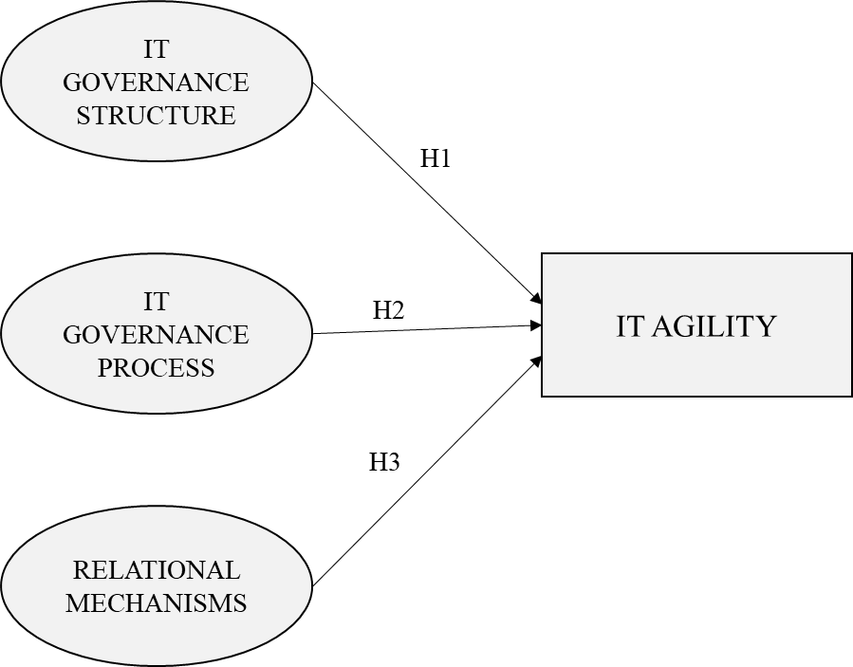
Figure 3: Conceptual Model

- RESEARCH METHODOLOGY
To investigate the first part of research question and test the hypotheses, a 3-part study was designed, combining both quantitative and qualitative approaches to provide a comprehensive understanding of the relationship between ITGMs and ITA.
- Focus Group Study: The first part of the study involved conducting a practitioner focus group to identify the ITGMs most likely related to ITA. The focus group consisted of structured discussions followed by a short survey, wherein the participants rated the relative importance of various ITGMs to ITA. Based on the results, 6 mechanisms of the ITG structure, 4 of the ITG process, and 4 relational mechanisms were identified for further investigation.
- Questionnaire Development and Survey: A questionnaire was developed to study the relationship between ITG and ITA, focusing on the 14 identified mechanisms. All of the items in the questionnaire were sourced from the existing literature. The questionnaire was then converted into an online survey format and distributed to mid-level and senior-level IT managers in Türkiye and the US. A total of 225 responses were obtained from IT professionals representing diverse roles, industries, and company sizes. Statistical analysis was conducted to investigate the hypotheses formulated based on the survey data.
- Follow-Up Focus Group Study: The final part of the study involved a follow-up practitioner focus group session to present the survey results. The goal of this session was to gain practitioner insights and facilitate sense-making of the findings. By engaging practitioners in the interpretation of the results, the study aimed to enhance the validity and relevance of the research findings.
The combination of quantitative analysis of the survey data and qualitative insights from the practitioner focus groups provided a robust research approach to investigate the important topic of ITG in relation to ITA. This combined approach allowed for triangulation of the findings, enabling a deeper understanding of the complex dynamics between ITGMs and organizational agility. Overall, this research methodology facilitated a comprehensive examination of the research question, contributing to the advancement of knowledge in the field of ITG.

Figure 4: Research Methodology of Research on Impact of ITG on ITA

Phase 1: Qualitative Analysis: Focus Group Study
The focus group method allows researchers to explore a specific topic by creating a discussion environment with a diverse group of participants (Belanger, 2012). The 3 aspects of focus group methods provide significant insights for IS researchers: First, IS researchers can study new topics to be explored; second, the focus group supports research where constructs emerge from group interaction; and third, focus groups can generate testable models and hypotheses for empirical testing.
In this study, the focus group was utilized to provide significant insight to develop an ITGM model to empirically analyze the role of ITA.
Focus groups can be highly structured with a prepared set of questions to ensure that there is no deviation from pre-set goals (Sobreperez & Sobreperez, 2008). In this study, the focus group was highly structured with pre-arranged questions. Diversified focus groups have an advantage in their ability to discuss complex topics from different perspectives (Klein et al., 2007). In this study, participants with different backgrounds, cultures, and countries were selected
All of the participants had more than 20 years’ experience in highly regulated industries, which means that they had plenty of knowledge and experience in implementing ITGMs.
Table 5: Focus group participants
ID | Role in Organization | Experience Years | Country
P1 | Lead Business Intelligence Analyst/ Chemical Industry | 20+ | USA
P2 | Information Security Director/ Information Security Production | 25+ | Türkiye
P3 | Senior Supervisor IT Auditor/Financial Industry | 20+ | USA
P4 | Information Security Services Leader/Consulting | 20+ | Türkiye
P5 | Head of Technology Risks/Financial Industry | 20+ | USA
P6 | Lead Security Engineer/Defense Industry | 20+ | Türkiye
P7 | Senior Risk Management Executive/Financial Industry | 20+ | USA

At the start of the focus group, the participants were informed about the study goals and the conceptual model. Consistent with conceptual model, ITG was described in terms of 3 mechanisms, as structure, processes, and relational, and ITA was described as the ability to sense and respond to the changes in the environment.
At the end of the focus group, the participants were expected to rate the ITGMs based on their importance and relevance to ITA on a scale of 1 to 10 (1: least relevant, 10: most relevant).
The pre-arranged question was, ‘Which components of the ITG structure, process, and relational mechanisms should be evaluated and considered to measure the ability of IT to sense and respond to the changes in the external environment?’ The participants were expected to rate the relevance and importance of each component to ITA on a scale of 1 to 10 (1: least relevant, 10: most relevant).

Table 6: Results of IT Governance Structure Rating
Components | P1 | P2 | P3 | P4 | P5 | P6 | P7 | Average
Alignment of governance and tasks while designing roles & responsibilities | 10 | 9 | 10 | 10 | 10 | 9 | 10 | 9.71
IT strategy committee | 10 | 9 | 10 | 8 | 9 | 9 | 10 | 9.29
IT security steering committee | 10 | 10 | 8 | 7 | 10 | 10 | 10 | 9.29
IT Steering Committee | 10 | 8 | 10 | 8 | 10 | 9 | 10 | 9.29
CIO on Board/Executive Committee | 7 | 10 | 10 | 8 | 9 | 10 | 10 | 9.14
Security / compliance /risk officer | 8 | 10 | 8 | 9 | 10 | 9 | 10 | 9.14
IT project steering committee | 8 | 9 | 10 | 8 | 8 | 10 | 10 | 9.00
CIO on direct reporting line | 10 | 10 | 10 | 10 | 10 | 10 | 2 | 8.86
Awareness of Board of directors about IT risks | 8 | 8 | 8 | 8 | 10 | 9 | 10 | 8.71
IT architecture committee | 7 | 7 | 10 | 8 | 9 | 9 | 10 | 8.57
IT Audit Committee | 10 | 9 | 2 | 9 | 10 | 9 | 10 | 8.43
IT Governance function/officer | 7 | 9 | 8 | 9 | 6 | 9 | 10 | 8.29
IT deployment Innovative skills | 6 | 8 | 8 | 9 | 9 | 8 | 7 | 7.86
The Budget Committee | 6 | 9 | 6 | 9 | 9 | 10 | 5 | 7.71
Centralized. Decentralized. Federal | 7 | 5 | 9 | 7 | 8 | 9 | 5 | 7.14
E-business advisory board | 6 | 5 | 10 | 9 | 6 | 9 | 5 | 7.14
E-business task force | 6 | 7 | 10 | 8 | 6 | 8 | 5 | 7.14
CIO appointed by Board | 7 | 9 | 2 | 9 | 5 | 8 | 5 | 6.43

Table 7: Results of IT Governance Process Rating
Components | P1 | P2 | P3 | P4 | P5 | P6 | P7 | Average
Strategic Information Systems Planning | 8 | 9 | 10 | 9 | 10 | 9 | 10 | 9.29
IT governance Framework such as COBIT and ITIL | 8 | 8 | 10 | 9 | 10 | 10 | 10 | 9.29
Business/IT alignment model | 8 | 10 | 10 | 8 | 10 | 9 | 10 | 9.29
IT performance measurement | 8 | 9 | 10 | 8 | 10 | 10 | 9 | 9.14
Benefits management and reporting | 7 | 9 | 10 | 9 | 8 | 10 | 10 | 9.00
Project governance /management methodologies | 8 | 9 | 10 | 8 | 10 | 8 | 8 | 8.71
A structured prioritization process for IT investments and projects involving both business and IT stakeholders | 8 | 8 | 10 | 9 | 10 | 8 | 8 | 8.71
COSO / ERM (Committee of Sponsoring Organization. Enterprise Risk management) | 7 | 8 | 8 | 9 | 10 | 8 | 10 | 8.57
Strategic Alignment Model | 8 | 7 | 8 | 9 | 10 | 8 | 9 | 8.43
Portfolio Management | 7 | 7 | 10 | 9 | 9 | 8 | 8 | 8.29
Technology Standardization and Infrastructure | 7 | 9 | 8 | 8 | 9 | 9 | 8 | 8.29
IT governance assurance and self-assessment | 8 | 9 | 2 | 9 | 10 | 9 | 10 | 8.14
Security audits are performed or organization’s security system is tested by outside agencies | 10 | 9 | 2 | 8 | 9 | 9 | 10 | 8.14
IT Budget Efficiencies/Control and Reporting | 7 | 9 | 5 | 7 | 9 | 10 | 8 | 7.86
Administrative Process | 8 | 6 | 8 | 9 | 8 | 7 | 8 | 7.71
Service level agreements | 8 | 8 | 2 | 8 | 9 | 8 | 10 | 7.57
Charge back arrangements- total cost of ownership | 7 | 8 | 2 | 9 | 8 | 8 | 5 | 6.71

Table 8: Results of Relational Mechanisms Rating
Components | P1 | P2 | P3 | P4 | P5 | P6 | P7 | Average
Cross-functional business/IT training | 10 | 8 | 10 | 8 | 10 | 10 | 10 | 9.43
Business-IT Collaboration is Enabled by Top Management | 10 | 9 | 10 | 8 | 10 | 9 | 10 | 9.43
IT Leadership | 9 | 9 | 10 | 8 | 10 | 9 | 10 | 9.29

Table 8 (cont.)
Shared understanding of business/IT objectives | 9 | 8 | 10 | 9 | 10 | 9 | 10 | 9.29
Encouraging communication between IT and business | 8 | 8 | 10 | 9 | 10 | 10 | 8 | 9.00
Executive/Senior management giving the good example | 8 | 10 | 10 | 8 | 10 | 7 | 10 | 9.00
Establishment of Business Process Documentation Platforms Between Business And IT | 7 | 10 | 10 | 9 | 8 | 8 | 10 | 8.86
Active participation and collaboration between principle stakeholders | 6 | 10 | 10 | 9 | 10 | 8 | 7 | 8.57
Senior executive/officer in charge of IT’s role | 8 | 9 | 8 | 9 | 10 | 8 | 8 | 8.57
Collaboration between principle stakeholders | 7 | 8 | 10 | 8 | 9 | 8 | 10 | 8.57
Partnership rewards and incentives | 6 | 9 | 10 | 9 | 8 | 9 | 8 | 8.43
Knowledge management (on IT governance) | 5 | 8 | 10 | 8 | 10 | 9 | 9 | 8.43
IT governance awareness campaigns | 7 | 9 | 8 | 9 | 8 | 8 | 10 | 8.43
Active Conflict Resolution | 9 | 9 | 8 | 8 | 9 | 8 | 8 | 8.43
Regular collaborative meetings to identify enhancements in business processes | 8 | 9 | 6 | 8 | 10 | 10 | 8 | 8.43
Business/IT account management | 8 | 8 | 10 | 9 | 9 | 9 | 5 | 8.29
Internal Corporate communication in which IT is involved on a regular basis | 8 | 8 | 8 | 8 | 9 | 7 | 7 | 7.86
Data Coordination with externals | 9 | 8 | 2 | 9 | 8 | 9 | 10 | 7.86
Job rotation | 5 | 4 | 10 | 9 | 5 | 7 | 7 | 6.71
Informal meetings between business and IT executive | 6 | 9 | 2 | 9 | 5 | 8 | 8 | 6.71
Business/IT co-location | 5 | 7 | 2 | 8 | 7 | 8 | 2 | 5.57

Table 8 lists all of the items that were rated above 9, which included 6 components of ITGSs, 4 components of ITG processes, and 4 components of relational mechanisms. These items were identified as the most relevant to ITA and served as the basis for the second part of the study – a survey of industry professionals in Türkiye and the USA.

Table 9: Rating Results of Focus Group Study with the Average Rating
IT Governance Mechanisms | Components | Average Rating
IT Governance Structure | Alignment of governance and tasks while designing roles & responsibilities | 9.71
 | IT strategy committee | 9.29
 | IT security steering committee | 9.29
 | IT Steering Committee | 9.29
 | CIO on Board/Executive Committee | 9.14
 | Security / compliance /risk officer | 9.14
IT Governance Process | Strategic Information Systems Planning | 9.29
 | IT governance Framework such as COBIT and ITIL | 9.29
 | Business/IT alignment model | 9.29
 | IT performance measurement | 9.14
Relational Mechanisms | Cross-functional business/IT training | 9.43
 | Business-IT collaboration is enabled by top management | 9.43
 | IT Leadership | 9.29
 | Shared understanding of business/IT objectives | 9.29

Based on the results of the participants’ ratings of each component for the ITGMs, the components with an average of more than 9 were put into the research model, as it was considered that those components would be more relevant to ITA.
To ascertain the components of ITG to be utilized in the research model, the assessment of each component was computed according to the ratings provided by the participants, employing the arithmetic mean instead of the median. Indeed, the utilization of the arithmetic mean instead of the median in determining the components of the ITG could potentially result in a different selection of components due to the differing statistical treatment of the data. However, the findings of the focus group study were thoroughly deliberated among the participants, lending credence to the validity and coherence of the selected components.

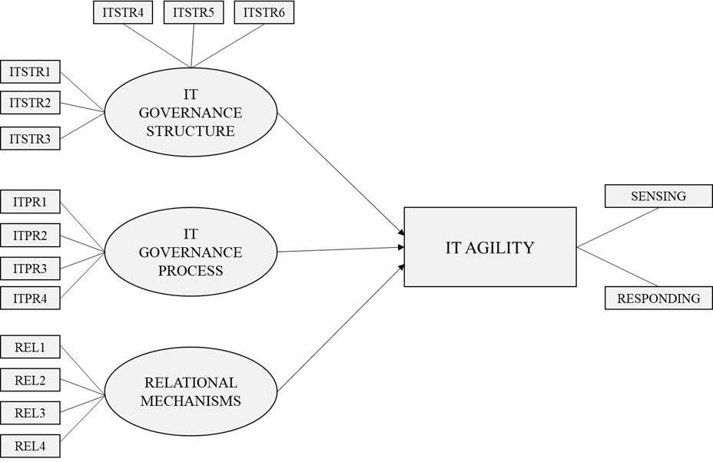
Figure 5: Research Model

For ITGSs, to sense and respond to the business changes, the integration of governance tasks in roles and responsibilities would be crucial. Similarly, constructing top management IT committees, such as an IT Strategy Committee and IT Security Steering Committee, would accelerate responses to the changes.
Processes represent the organization’s strategy systems planning to monitor the results of IT assessment by the ITG framework and business/IT alignment model, and IT performance measurement would potentially decrease the response time to business changes and increase adaptability to the technology environment.
Enhancing the connection between business and IT could strengthen with cross-functional business/IT training, and top management support for business-IT collaboration and IT leaderships’ shared understanding of business/IT objectives would also potentially increase ITA for organizations.

Hence, the research model consisted of 14 components for ITGMs and 2 components for ITA to test the hypotheses.

Table 10: Research Model Components
Label | Research Model Components
ITSTR1 | Alignment of governance and tasks while designing roles & responsibilities
ITSTR2 | IT Strategy Committee
ITSTR3 | IT Security Steering Committee
ITSTR4 | IT Steering Committee
ITSTR5 | CIO on Board/Executive Committee
ITSTR6 | Security / Compliance /Risk Officer
ITPR1 | Strategic Information Systems Planning
ITPR2 | IT governance Framework such as COBIT and ITIL
ITPR3 | Business/IT Alignment Model
ITPR4 | IT Performance Measurement
REL1 | Training sessions that integrate both business and IT functions across departments
REL2 | Business-IT collaboration is enabled by top management
REL3 | IT Leadership
REL4 | Mutual Comprehension of business/IT objectives

Phase 2: Quantitative Analysis: Survey
A survey was designed to test the hypotheses as a follow-up to the focus group. The focus group of industry professionals aided in identifying a more specific and potentially relevant set of ITGMs to explore the relationship with ITA.
As the output of the focus group study, it was determined that the well-defined roles and responsibilities of IT individuals and having IT committees in senior management could have a potential impact on ITA. Similarly, constructing proper IT processes and implementing IT standards could have a positive impact on reacting to business changes. Finally, it was thought that strengthening communication between IT and business would strengthen their IT sense and response to market changes.

Instrument Development
A survey was designed to test the hypotheses as a follow-up to the focus group. The focus group of industry professionals aided in identifying a more specific and potentially relevant set of ITGMs to explore the relationship with ITA.
As the output of the focus group study, it was determined that the well-defined roles and responsibilities of IT individuals and having IT committees in senior management could have a potential impact on ITA. Similarly, constructing proper IT processes and implementing IT standards could have a positive impact on reacting to business changes. Finally, it was thought that strengthening communication between IT and business would strengthen their IT sense and response to market changes.
Table 11: Survey Questions of Research Constructs
Construct | Survey Questions | Reference
IT Governance Structure | Roles and responsibilities are clearly documented, encompassing governance and alignment tasks that involve both business and IT professionals. | (de Haes & van Grembergen, 2009)
 | IT Strategy Committee: A board-level committee established within the organization to ensure that IT is regularly included as an agenda item and reporting issue for the board of directors. | (de Haes & van Grembergen, 2009)
 | IT Security Steering Committee: A steering committee comprising both business and IT professionals is established within the organization to collaboratively prioritize and oversee the management of IT investments on security issues. | (Héroux & Fortin, 2014)
 | IT Steering Committee: A steering committee at the executive or senior management level is established to assess and determine the business requirements for IT investments within the organization. | (de Haes & van Grembergen, 2009)
 | CIO on Board/Executive Committee: The organization has a Chief Information Officer (CIO) who is a member of the Executive Committee. | (Wu et al., 2015)
 | Security/Compliance/Risk Officer: There is a dedicated function within our organization responsible for managing security, compliance, and/or risk, which may have a significant impact on IT operations. | (de Haes & van Grembergen, 2009)

Table 11 (cont.)
IT Governance Processes | Strategic Information Systems Planning: A formal process is in place to develop and uphold the IT strategy within the organization. | (de Haes & van Grembergen, 2009)
 | IT governance Framework such as COBIT and ITIL: There is processes-based IT Governance and Control Framework such as COBIT and ITIL in place in our organization. | (de Haes & van Grembergen, 2009)
 | Business/IT Alignment Model: There is a process to implement a methodology to succeed alignment of IT structure and business needs. | (Zhen et al., 2021)
 | IT Performance Measurement: There is IT performance measurements in place, which encompass corporate contributions, user requirements, operational excellence, and future orientation, such as an IT balanced scorecard. | (de Haes & van Grembergen, 2009)
Relational Mechanisms | Cross-functional business/IT training: There is a training program in place to educate both business professionals about IT and IT personnel about business concepts. | (de Haes & van Grembergen, 2009)
 | Top management support for business-IT collaboration: Business-IT collaboration is enabled by top management | (Schlosser et al., 2015)
 | IT Leadership: There is a CIO or similar role to establish a vision for IT’s role in the organization to enable IT vision is accepted by managers across the organization. | (de Haes & van Grembergen, 2009)
 | Common understanding of business/IT objectives: There is mutual comprehension of business/IT objectives throughout business and IT people. | (Lunardi et al., 2014)

Dataset
As a first step of conducting the survey, a prior questionnaire was prepared using items of ITGMs given in Section 4.2.1 to verify if the constructs derived from literature were understandable and acceptable for IT professionals. The pilot study was sent to the participants of the focus group study and minor changes were made to the questionnaire based on their feedback.
As a second step, the final version of the questionnaire was distributed to the IT professionals. The intended respondents for the questionnaire were IT professionals with plenty of knowledge of ITG. Additionally, the explanations of each item of the ITGMs were included in the questionnaire for clarity.
An online survey was created and mid-level and senior-level IT managers were contacted through LinkedIn. For each LinkedIn contact, the goal of the research was introduced and participation was requested. It was possible to obtain 225 responses with a 41% response rate from a variety of IT professionals with plenty working experience in the field of IT.
Adding to their experience, the respondents were working in different industries and the sizes of their firms also varied, which enriched the dataset. The number of participants was about evenly split across Türkiye and the USA. The aim of sending the questionnaire to the different locations was to assess if the maturity level of ITGMs would make a difference on responding to the market changes. To explore the characteristics of the dataset, Tables 12 to 17 were constructed. In Table 12, it can be seen that participants from all position levels, from specialist to the senior executive, responded to the questionnaire.
Table 12- Statistics for Positions of Participants
Position | Frequency | Percent
Senior Executive | 16 | 7,1
Head of Department | 58 | 25,8
Specialist/Senior Specialist | 35 | 15,6
Executive Director | 64 | 28,4
Team Leader | 52 | 23,1
Total | 225 | 100,0

Table 13- Experience Years of Participants
Experience Years | Frequency | Percent
1-10 | 45 | 20,0
11-20 | 89 | 39,6
21-30 | 70 | 31,1
30+ | 21 | 9,3
Total | 225 | 100,0

Responses were obtained from participants that work in different industries. Some of which were highly regulated industries, such as finance and insurance, and others were moderately regulated by state authorities. The purpose of sending the questionnaire to IT professionals from different industries was to assess if regulations over a variety industries have an impact on the maturity level of ITGMs. (see Table 14).
Table 14- Industry of the Participants’ Companies
 | Frequency | Percent
Education | 7 | 3,1
E-Commerce | 44 | 19,6
Construction | 5 | 2,2
Manufacturing | 29 | 12,9
Transportation, Communication, Electric, Gas and Sanitary Service | 13 | 5,8
Wholesale Trade / Retail Trade | 16 | 7,1
IT | 15 | 6,7
Finance and Insurance | 28 | 12,4
Public Administration | 9 | 4,0
Health Services | 17 | 7,6
Defense and Aerospace | 23 | 10,2
Others | 19 | 8,4
Total | 225 | 100,0

In the dataset, there were 112 responses from Türkiye and 113 responses from the USA which enabled equal distribution between the locations of the firms that the participants work at (see Table 15).
Table 15- Location of the Companies
Location of the Companies | Frequency | Percent
Türkiye | 113 | 50,2
USA | 112 | 49,8
Total | 225 | 100,0

Additionally, data were collected from participants who worked in different sized firms, which could potentially have an impact on IT process and IT structures (see Table 16).

Table 16- Company Size: Number of Employees of the Companies
Number of Employees of the Companies | Frequency | Percent
1-100 | 9 | 4,0
101-500 | 20 | 8,9
501-2500 | 52 | 23,1
2501-10000 | 46 | 20,4
10001-25000 | 45 | 20,0
25000+ | 53 | 23,6
Total | 225 | 100,0

Data on the IT size of organizations was gathered. The ratio of IT size relative to company size may vary depending on the industries in which the companies operate, as these companies position their IT organizations at different levels of management (see Table 17).
Table 17- IT Size: Number of IT Employees
Number of IT Employees | Frequency | Percent
1-10 | 23 | 10,2
11-50 | 37 | 16,4
51-100 | 22 | 9,8
101-250 | 41 | 18,2
251-1000 | 22 | 9,8
1001-2500 | 37 | 16,4
2500+ | 43 | 19,1
Total | 225 | 100,0

Semi-Structured Interviews About the Centralization of ITG

Figure 6: Research Methodology of Research on Centralization of ITG
Regarding the second part of the research, the study followed a qualitative approach by interviewing 11 senior employees who have at least 10 years’ experience and plenty of knowledge about ITG. All of the participants worked in the same technology firm that was selected for this study. The firm has centralized and decentralized ITG functions that serve 10.000+ employees’ technological needs. The participants were selected based on their role in the organization, as their roles require them to understand the needs of ITG.

Table 18. Questions to the Interviewees
Number | Questions
1 | May you give us some information about your roles, responsibilities, and experiences in your organization?
2 | According to your experiences, which way is the best to provide or get IT services (either fully centralized, fully decentralized, or hybrid based on the needs)?
3 | Regarding your experiences, what is the most significant benefit of centralizing IT services?
4 | Regarding your experiences, what is the biggest problem of centralizing IT services?
The participants were asked 5 questions to get their insight about how IT decision making mechanisms should be placed in the firm that they work at. They responded to the questions not only based on their experience in that firm but also based on their previous experience and their knowledge (see Table 18).

CHAPTER 4

DATA ANALYSIS AND RESULTS
In this section, the statistical data analysis and interpretation of the outcomes are introduced. The Analysis of Variance (ANOVA), CB-SEM, and PLS-SEM methods were used by utilizing IBM SPSS, AMOS, and Smart PLS software. After obtaining the statistical results, the outcomes were discussed with the IT professional to understand what the outcomes would mean in practice.

Preliminary Analysis
In this study, the responses to the questionnaire were designed as scaled-responses and a Likert scale was utilized to measure to what extent the respondents aligned with the statement. This study utilized a 5-point Likert scale ranging from Strongly Disagree: 1 to Strongly Agree: 5.

The independent sample t-test was used for the firm location variable to determine whether the variable measured in the study differed according to various demographic variables, while ANOVA was carried out for the variables of the firm size and industry utilizing SPSS. Before the analysis, a homogeneity (Levine) test of the variances was performed. After it was determined that the group variances were homogeneous, 1-way ANOVA was performed to determine the differences between the groups.

The t-test results regarding whether the research variables, and ITG structure, process, and relational mechanisms differed according to the firm location are shown in Table 19. Based on the findings, it was determined that the ITG structure, process, and relational mechanisms research variables differed statistically significantly according to the firm locations as the p-values were smaller than 0.005.

The ANOVA results regarding whether the research variables differed from the demographic variables according to the firm size and industry are shown in Table 20. According to the Dunnett T3 test findings, it was determined that the average score obtained from the research variables and the ITG structure, process, and relational mechanisms differed according to the firm size and industry.

As the size of a firm, as measured by the number of employees, increased, there tended to be a greater emphasis on structured ITGMs within the organization. This observation implies that larger firms are more likely to have well-defined frameworks and processes in place for managing their IT functions.

Specifically, in larger companies, it is more common to find a higher level of IT knowledge and expertise among upper management. This indicates that senior executives in larger firms are more actively involved in IT decision-making and strategy, recognizing the importance of aligning IT initiatives with overall business objectives.

Table 19- Firm Location
Variables | Groups | N | χ | Standard Deviation | t | sd | p
ITGS | Türkiye | 113 | 4.011 | 0.928 | -4.006 | 195.481 | 0.001
 | USA | 112 | 4.433 | 0.619
ITGP | Türkiye | 113 | 3.873 | 1.015 | -3.309 | 204.827 | 0.001
 | USA | 112 | 4.265 | 0.740
RM | Türkiye | 113 | 3.878 | 0.895 | -2.934 | 212.641 | 0.024
 | USA | 112 | 4.194 | 0.709
ITA | Türkiye | 113 | 3.924 | 0.892 | -1.896 | 211.498 | 0.007
 | USA | 112 | 4.123 | 0.697

Moreover, larger organizations are more likely to adhere to established ITG frameworks and standards, ensuring consistency and compliance across IT processes and operations. This adherence to governance best practices helps mitigate risks, enhance operational efficiency, and promote better decision making related to IT investments and initiatives.

Furthermore, in larger firms, there tends to be a greater alignment and mutual comprehension between the business and IT objectives. This alignment facilitates collaboration and communication between different departments and functions, enabling IT to better support and contribute to the organization's strategic goals and objectives.

Table 20- Firm Size
Variables | Firm Size | N | χ | Standard Deviation | F | p | Significant Difference | Eta Squared
ITGS | 1-100 | 9 | 3.500 | 0.971 | 9.014 | 0.001 | 3-5. 3-6. 4-5 | 0.171
 | 101-500 | 20 | 4.058 | 0.963
Table 20 (cont.)
 | 501-2500 | 52 | 3.839 | 0.858
 | 2501-10000 | 46 | 4.119 | 0.853
 | 10001-25000 | 45 | 4.618 | 0.507
 | 25000+ | 53 | 4.531 | 0.569
ITGP | 1-100 | 9 | 3.027 | 0.947 | 9.291 | 0.001 | 1-5. 1-6. 3-5. 3-6. 4-5. 4-6 | 0.175
 | 101-500 | 20 | 3.825 | 1.112
 | 501-2500 | 52 | 3.735 | 0.966
 | 2501-10000 | 46 | 3.929 | 0.922
 | 10001-25000 | 45 | 4.444 | 0.598
 | 25000+ | 53 | 4.467 | 0.622
RM | 1-100 | 9 | 3.611 | 0.730 | 5.820 | 0.001 | 3-5. 3-6. 4-5. 4-6 | 0.117
 | 101-500 | 20 | 3.937 | 0.910
 | 501-2500 | 52 | 3.831 | 0.764
 | 2501-10000 | 46 | 3.739 | 0.960
 | 10001-25000 | 45 | 4.261 | 0.621
 | 25000+ | 53 | 4.410 | 0.697
ITA | 1-100 | 9 | 3.750 | 0.480 | 5.987 | 0.001 | 3-6. 4-5. 4-6 | 0.120
 | 101-500 | 20 | 3.812 | 0.894
 | 501-2500 | 52 | 3.872 | 0.862
 | 2501-10000 | 46 | 3.676 | 0.911
 | 10001-25000 | 45 | 4.300 | 0.575

Table 20 (cont.)
 | 25000+ | 53 | 4.353 | 0.636

Indeed, the study revealed that industries characterized by high regulation, such as finance, insurance, and healthcare, as well as technology-focused sectors like e-commerce and IT, tended to exhibit more mature ITGMs.
These findings suggest that regulatory requirements and the complexity of technological operations in these industries necessitate more robust governance structures and processes. Organizations operating within these sectors must adhere to stringent compliance standards and manage complex IT infrastructures, prompting them to invest in sophisticated governance frameworks.
Table 21- Firm Industry
Variables | Industry | N | χ | Standard Deviation | F | p | Significant Difference | Eta Squared
ITGS | Education | 7 | 3.214 | 1.065 | 5.033 | 0.001 | 2-4. 2-11. 4-8. 8-10. 8-11 | 0.206
 | E-Commerce | 44 | 4.598 | 0.647
 | Construction | 5 | 3.966 | 1.430
 | Manufacturing | 29 | 3.959 | 0.715
 | Transportation, Communication, Electric, Gas and Sanitary Service | 13 | 4.474 | 0.535
 | Wholesale Trade / Retail Trade | 16 | 4.145 | 0.856
 | IT | 15 | 4.233 | 0.969
 | Finance and Insurance | 28 | 4.744 | 0.375
 | Public Administration | 9 | 4.111 | 0.781

Table 21 (cont.)
 | Health Services | 17 | 4.098 | 0.629
 | Defense and Aerospace | 23 | 3.724 | 0.779
 | Others | 19 | 4.061 | 0.915
ITGP | Education | 7 | 3.250 | 1.181 | 3.766 | 0.001 | 4-8. 8-10. 8-11. 8-12 | 0.163
 | E-Commerce | 44 | 4.323 | 0.778
 | Construction | 5 | 3.700 | 1.555
 | Manufacturing | 29 | 3.784 | 0.870
 | Transportation, Communication, Electric, Gas and Sanitary Service | 13 | 4.192 | 0.744
 | Wholesale Trade / Retail Trade | 16 | 3.921 | 1.035
 | IT | 15 | 4.083 | 1.104
 | Finance and Insurance | 28 | 4.767 | 0.419
 | Public Administration | 9 | 4.055 | 0.966
 | Health Services | 17 | 4.073 | 0.535
 | Defense and Aerospace | 23 | 3.641 | 0.934
 | Others | 19 | 3.828 | 0.870
RM | Education | 7 | 3.000 | 1.080 | 3.969 | 0.001 | 4-8. 8-11. | 0.170
 | E-Commerce | 44 | 4.022 | 0.911
 | Construction | 5 | 3.750 | 1.380
 | Manufacturing | 29 | 3.956 | 0.627

Table 21 (cont.)
 | Transportation, Communication, Electric, Gas and Sanitary Service | 13 | 4.076 | 0.759
 | Wholesale Trade / Retail Trade | 16 | 4.093 | 0.784
 | IT | 15 | 4.300 | 0.768
 | Finance and Insurance | 28 | 4.607 | 0.550
 | Public Administration | 9 | 4.250 | 0.875
 | Health Services | 17 | 4.102 | 0.433
 | Defense and Aerospace | 23 | 3.489 | 0.802
 | Others | 19 | 4.013 | 0.679
ITA | Education | 7 | 3.357 | 1.107 | 3.765 | 0.001 | 2-8. 2-10. 2-11. 11-12 | 0.163
 | E-Commerce | 44 | 3.974 | 0.926
 | Construction | 5 | 3.525 | 1.453
 | Manufacturing | 29 | 4.103 | 0.634
 | Transportation, Communication, Electric, Gas and Sanitary Service | 13 | 3.951 | 0.806
 | Wholesale Trade / Retail Trade | 16 | 4.078 | 0.605
 | IT | 15 | 4.375 | 0.786
 | Finance and Insurance | 28 | 4.567 | 0.469
 | Public Administration | 9 | 3.875 | 1.011
Table 21 (cont.)
 | Health Services | 17 | 3.889 | 0.533
 | Defense and Aerospace | 23 | 3.440 | 0.769
 | Others | 19 | 4.184 | 0.481

The statistical analysis revealed significant differences in the research variables based on the firm location, size, and industry. Consequently, these variables were incorporated into the research model as control variables to address their potential impact on the association between ITGMs and ITA, as shown in Figure 7.
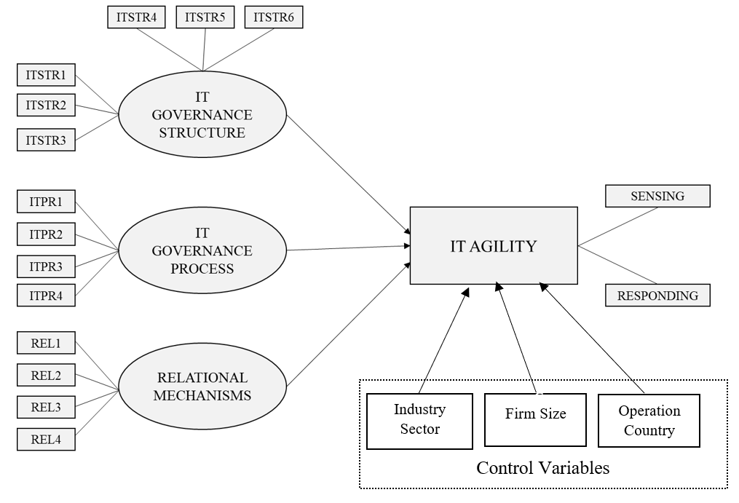
Figure 7: Research Model with Control Variables

Covariance Structural Equation Modeling (CB-SEM)
Modern SEM originated from biologist Sewall Wright’s development of path analysis (Hancock & Mueller, 2013). Karl Jöreskog developed a method for confirmatory factor analysis (CFA), which is an application of the maximum likelihood theory to factor models with a specific hypothesized theoretical latent structure. Hence, Wright’s measured variable path analysis and Jöreskog’s CFA were combined, and consequently, SEM was quietly born (Hancock & Mueller, 2013). SEM can be defined as a combination of statistical techniques that enables one to examine relationships between one or more independent variables, which could be continuous or discrete, and one or more dependent variables (Ullman & Bentler, 2012).
As SEM is well fit to analyze the proposed model, the proposed model was validated by CFA and the proposed hypotheses were tested by SEM using the AMOS software package.

Measurement Model
As estimation techniques covered in SEM assume multivariate normality, the normality of the dataset needs to be examined by checking the skewness and kurtosis of the distribution for the measured variables (Ullman & Bentler, 2012). Hence, since the dataset was greater than 200, skewness and kurtosis should be between –2.58 and 2.58 with a significance level of 0.01 (Hair et al., 2014), which enables us to reach a point where the normality assumption is satisfactory.
To assess the reliability of the measurement items, the Cronbach’s alpha for each construct was checked. The values were greater than 0.7, which ensured the reliability of the measurement (Hair et al., 2014).

Table 22- Cronbach’s Alpha Measures and Normality Test of Items
Item | Kolmogorov-Smirnov | Sig. (p) | Skewness | Kurtosis | Cronbach’s Alpha
ITGS | 0.174 | 0.001 | -1.130 | 0.799 | 0.858
ITGP | 0.154 | 0.001 | -1.054 | 0.725 | 0.859
RM | 0.120 | 0.001 | -0.797 | 0.295 | 0.856
ITA | 0.113 | 0.001 | -0.910 | 0.632 | 0.951

Reliability and Validity of the Model and Model Fit
In order to assess the reliability of the measurement items, the Cronbach’s alpha for each construct was checked. As the values were greater than 0.7, which ensured the reliability of the measurement (Hair et al., 2014) (see Table 23).

To assess convergent validity, the values of average variance extracted (AVE) and composite reliability (CR) of each construct were checked, where the AVE value should be greater than 0.5 and the CR value should be greater than 0.7 (Hair et. al). It was found that the proposed constructs satisfied the convergent validity (see Table 24).

Table 23- Cronbach's Alpha Measures of the Scale Items
Construct | Cronbach’s Alpha | N of Items
IT Governance Structure | 0.858 | 6
IT Governance Process | 0.859 | 4
Relational Mechanisms | 0.856 | 4
IT Agility | 0.951 | 8

Table 24- Convergent Validity Test Results

Construct | Items | Regression Weights | AVE  >0.5 | CR  >0.7
IT Governance Structure | ITG1 | 0.859 | 0.593 | 0.897
 | ITG2 | 0.818
 | ITG3 | 0.808
 | ITG4 | 0.723
 | ITG5 | 0.713
 | ITG6 | 0.685
IT Governance Process | ITP1 | 0.867 | 0.715 | 0.909
 | ITP2 | 0.864
 | ITP3 | 0.835
 | ITP4 | 0.815
Relational Mechanisms | RM1 | 0.886 | 0.708 | 0.906
 | RM2 | 0.869
 | RM3 | 0.843
 | RM4 | 0.762

Table 24 (cont.)
IT Agility | ITA1 | 0.915 | 0.751 | 0.960
 | ITA2 | 0.896
 | ITA3 | 0.877
 | ITA4 | 0.875
 | ITA5 | 0.871
 | ITA6 | 0.84
 | ITA7 | 0.829
 | ITA8 | 0.826

Performing CFA was a crucial step in validating the proposed model. This analysis helped to ensure that the selected measurement items adequately represented the underlying constructs and assessed the model’s overall fit with the data.

Using SPSS AMOS, the CFA was conducted by specifying the proposed model, including the latent constructs (e.g., ITG structure, process, relational mechanisms, ITA) and their respective observed indicators (e.g., the survey items). The analysis aimed to assess the reliability and validity of the measurement model.

The following steps were taken during the CFA process:
- Internal consistency reliability was evaluated using the Cronbach’s alpha coefficient for each latent construct. Moreover, convergent validity was verified by confirming significant loading of all of the indicators on their respective constructs. Discriminant validity was assessed by comparing the square root of the AVE with the correlations between the constructs. Table 24 shows that the proposed constructs satisfied the convergent validity.
- Indicator Loading Estimation: Estimates of factor loadings (λ) were obtained to assess the strength of the relationship between each indicator and its corresponding latent construct. These factor loadings should ideally be statistically significant and preferably above 0.5 to demonstrate adequate measurement. Table 25 shows the related item loadings.

Table 25- Item loadings and cross loadings
 |  | Factor Analysis
Construct | Item | ITA | ITGP | ITGS | RM
ITA | ITA1 | .868 | .569 | .430 | .671
 | ITA2 | .889 | .533 | .414 | .683
 | ITA3 | .911 | .580 | .495 | .736
 | ITA4 | .873 | .609 | .488 | .715
 | ITA5 | .831 | .489 | .339 | .619
 | ITA6 | .850 | .525 | .432 | .674
 | ITA7 | .833 | .513 | .470 | .660
 | ITA8 | .874 | .575 | .513 | .673
ITGP | ITGP1 | .515 | .825 | .716 | .634
 | ITGP2 | .505 | .843 | .637 | .600
 | ITGP3 | .606 | .845 | .643 | .669
 | ITGP4 | .532 | .865 | .638 | .651
ITGS | ITGS1 | .518 | .646 | .703 | .522
 | ITGS2 | .283 | .583 | .830 | .496
 | ITGS3 | .430 | .614 | .796 | .514
 | ITGS4 | .467 | .702 | .848 | .596
 | ITGS5 | .381 | .502 | .718 | .516
 | ITGS6 | .359 | .573 | .707 | .417
RM | RM1 | .560 | .668 | .512 | .797
 | RM2 | .665 | .660 | .637 | .854
 | RM3 | .691 | .579 | .532 | .828
 | RM4 | .729 | .609 | .551 | .879

- Assessment of Model Fit: Different fit indices were scrutinized to assess the adequacy of the proposed model in explaining the observed data. These commonly used fit indices include the Comparative Fit Index (CFI), Tucker-Lewis Index (TLI), Root Mean Square Error of Approximation (RMSEA), and Standardized Root Mean Square Residual (SRMR). A good fit is indicated by CFI and TLI values close to or above 0.95, and RMSEA and SRMR values close to or below 0.08. Table 25 shows that the proposed model fit the observed data.

By conducting CFA in SPSS AMOS, the validity and reliability of the proposed model were assessed, providing confidence in the measurement of latent constructs and paving the way for subsequent SEM analyses.

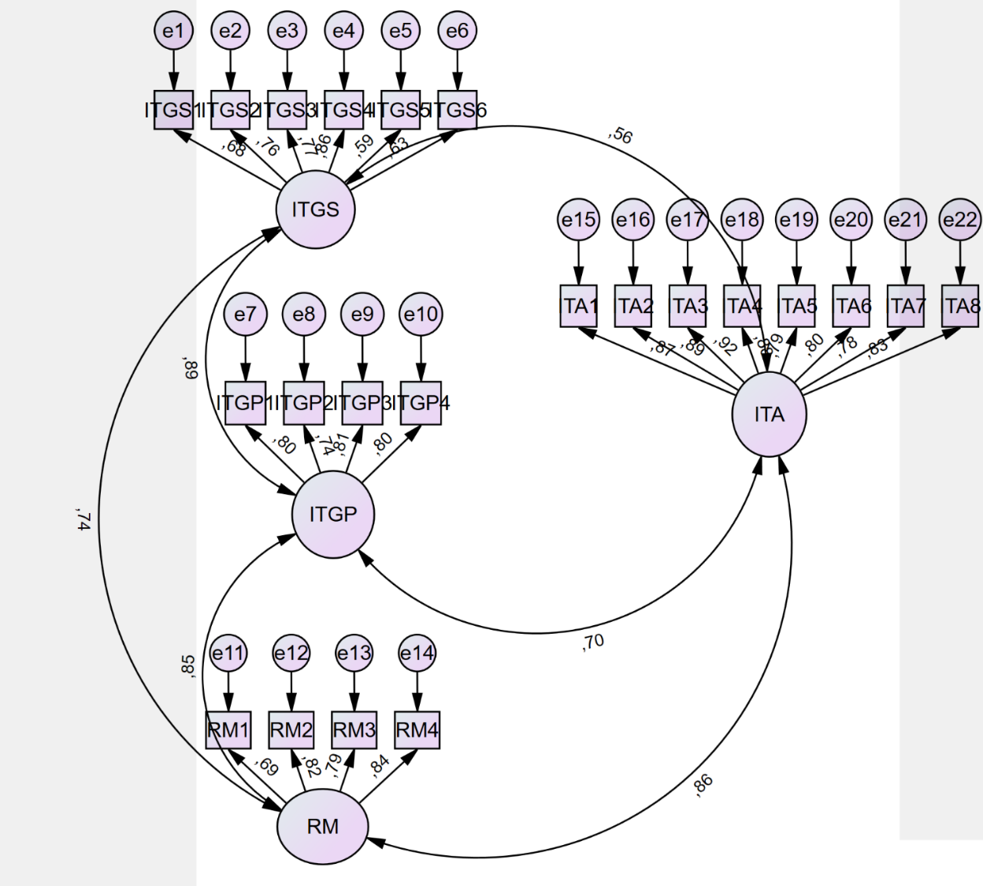
Figure 8: CFA Model

In the first run of the CFA, although the model fit indices were at an acceptable level, some modifications were made by correlating the errors of the constructs of the ITGSs and ITA, which improved the model fit indices.

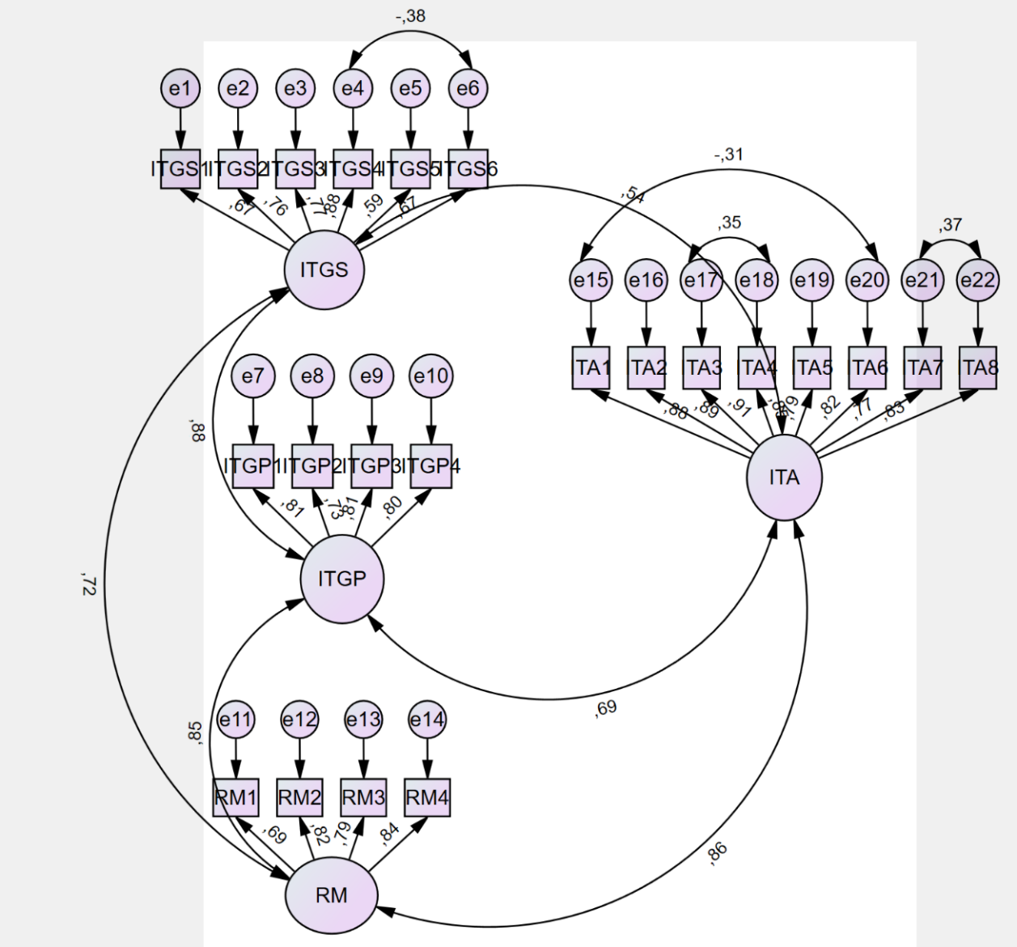
Figure 9: Modified CFA Model
Table 26- Statistics of goodness of fit in structural equation modeling

Fit Indexes |  | Good Fit | Acceptable Fit | Model (Before Modification) | Model (After Modification)
Normed Chi Square | χ2/df | ≤3 | 3≤χ2/df≤5 | 2.709 | 2.356
Goodness of Fit Index | GFI | ≥0.95 | ≥0.90 | 0.815 | 0.846
Comparative Fit Index | CFI | ≥0.95 | ≥0.90 | 0.912 | 0.932
Tucker–Lewis index | NNFI (TLI) | ≥0.95 | ≥0.90 | 0.900 | 0.921
Table 26 (cont.)
Normed Fit Index | NFI | ≥0.95 | ≥0.90 | 0.869 | 0.888
Incremental fit index | IFI | ≥0.95 | ≥0.90 | 0.913 | 0.932
Root mean square error of approximation | RMSEA | ≤0.05 | ≤0.08 | 0.087 | 0.078
χ2  Degrees of Freedom | χ2  df |  |  | 549.867  203 | 468.840  199
Significant | P |  |  | 0.000 | 0.000

Structural Model and Hypotheses Testing
In order to test the proposed hypotheses and assess the relationships between the ITGMs and ITA, SEM analysis was conducted using SPSS AMOS.
The SEM model was constructed based on the conceptual framework developed in the study, which outlined the relationships between the ITGMs (including structure, process, and relational mechanisms) and ITA.
Once the SEM model was specified, it was executed using SPSS AMOS to analyze the data collected from the survey. The analysis involved estimating the parameters of the model and assessing the fit of the model to the observed data.
The results of the SEM analysis provided insights into the relationships between the ITGMs and ITA, allowing for the testing of the proposed hypotheses. Additionally, any significant indirect effects or moderating effects identified in the model were interpreted to further understand the mechanisms through which ITG influences ITA.
Overall, the SEM analysis conducted in SPSS AMOS served as a robust method for testing the proposed hypotheses and examining the complex relationships between the ITGMs and ITA in the context of the study.
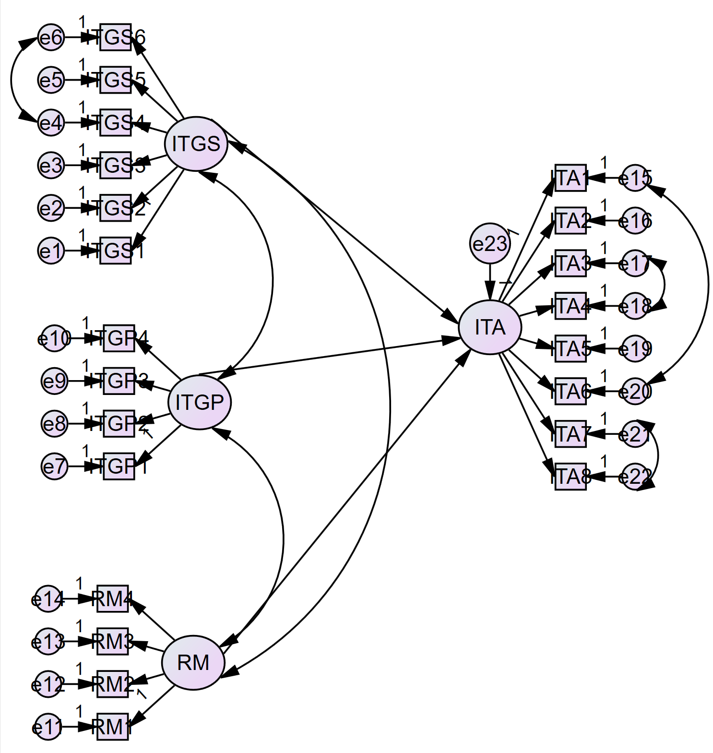
Figure 10: SEM of the Proposed Model

The results of the SEM analysis revealed several important findings regarding the relationship between the ITGMs and ITA.
First, it was concluded that there is no significant relationship between the ITGSs and ITA. This suggests that the specific organizational structures put in place for ITG, such as committees or decision-making hierarchies, do not directly impact an organization’s ability to respond and adapt to changes in the business environment.
Similarly, the analysis found that the IT process also does not have a significant impact on ITA. This implies that the specific processes and procedures implemented for ITG, such as the ITIL frameworks or project management methodologies, do not directly contribute to an organization’s agility in responding to market changes.
However, the results did show that relational mechanisms have a significant positive impact on ITA. Relational mechanisms, which involve communication and collaboration between IT and business stakeholders, were found to be crucial for enhancing an organization’s ability to sense and respond to changes in the business environment.

Table 27- Result of Proposed Model
 |  | Estimates | P-Value | Results
H1 | ITA<---ITGS | -0.323 | 0.076 | Significant relationship doesn’t exist.
H2 | ITA<---ITGP | 0.113 | 0.545 | Significant relationship doesn’t exist.
H3 | ITA<---RM | 0.934 | 0.000 | Accepted.

The separate analyses of the SEM model for companies in Türkiye and the USA revealed interesting differences in the impact of ITGMs on ITA.
In companies located in the USA, it was found that the ITG structure and relational mechanisms both have a significant impact on ITA, supporting hypotheses H1 and H3. This suggests that in the USA context, both the organizational structures for ITG and the relationships between IT and business stakeholders play important roles in enhancing ITA. However, the ITG process was found to have no significant impact on ITA, contrary to hypothesis H2.

Table 28- Result of Proposed Model for USA
 |  | Estimates | P-Value | Results
H1 | ITA<---ITGS | -0.585 | 0.010 | Accepted.
H2 | ITA<---ITGP | 0.083 | 0.628 | Significant relationship doesn’t exist.
H3 | ITA<---RM | 1.189 | 0.000 | Accepted.

On the other hand, in Türkiye, the results showed that the ITGSs do not have a significant impact on ITA. This finding suggests that in Türkiye, the specific organizational structures put in place for ITG may not directly contribute to an organization’s ability to respond and adapt to changes in the business environment. However, similar to the findings in the USA, relational mechanisms were found to have a significant impact on ITA.

Table 29- Result of Proposed Model for Türkiye
 |  | Estimates | P-Value | Results
H1 | ITA<---ITGS | -0.113 | 0.681 | Significant relationship doesn’t exist.
H2 | ITA<---ITGP | -0.018 | 0.953 | Significant relationship doesn’t exist.
H3 | ITA<---RM | 0.952 | 0.000 | Accepted.

Partial Least Squares Structural Equation Modeling (PLS-SEM)
As an alternative to the CB-SEM method, the PLS-SEM was conducted using the SmartPLS application to examine if the findings would be consistent. PLS-SEM offers the advantage of estimating complex models with various constructs and indicator variables, with relatively smaller sample size requirements compared to factor-based SEM methods (Sarstedt et al., 2022). PLS can serve as a viable alternative to CB-SEM when the phenomenon under investigation and measurement models are newly developed, the proposed model is intricate, sample size and normal distribution requirements are not met, and/or the research aims at prediction rather than parameter estimation (Urbach et al., 2010).

Smart PLS4 was utilized as the software for this purpose.

Confirmatory Factor Analysis (CFA)
Similar to CB-SEM, CFA was conducted to evaluate the reliability and validity of the constructs. With a Cronbach’s alpha exceeding 0.7, construct reliability was confirmed. Additionally, with CR values surpassing 0.6 and AVE values exceeding 0.5, convergent validity was established.
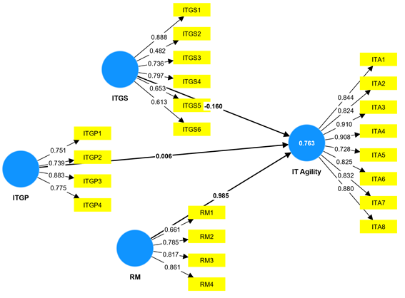
Figure 11: CFA of PLS-SEM Model

Table 30- Construct Reliability and Validity

Construct | Item | Loading | VIF | Cronbach’s Alpha | CR | AVE
ITA | ITA1 | 0.844 | 4.004 | 0.952 | 0.954 | 0.715
 | ITA2 | 0.824 | 4.386
 | ITA3 | 0.910 | 5.991
 | ITA4 | 0.908 | 4.152
 | ITA5 | 0.728 | 2.627
 | ITA6 | 0.825 | 2.932
 | ITA7 | 0.832 | 2.942
 | ITA8 | 0.880 | 3.577
ITGP | ITGP1 | 0.751 | 1.989 | 0.867 | 0.872 | 0.622
 | ITGP2 | 0.739 | 1.847
 | ITGP3 | 0.883 | 2.272
 | ITGP4 | 0.775 | 2.296
ITGS | ITGS1 | 0.888 | 1.649 | 0.861 | 0.873 | 0.500
 | ITGS2 | 0.482 | 2.298
 | ITGS3 | 0.736 | 2.231
Table 30 (cont.)
 | ITGS4 | 0.797 | 2.870
 | ITGS5 | 0.653 | 1.569
 | ITGS6 | 0.613 | 1.597
RM | RM1 | 0.661 | 1.676 | 0.861 | 0.871 | 0.615
 | RM2 | 0.785 | 2.409
 | RM3 | 0.817 | 2.221
 | RM4 | 0.861 | 2.528

In the CFA process, item loadings and cross-loadings are examined to assess the relationship between observed indicators (items) and latent constructs. Item loadings indicate the strength of association between each item and its intended construct, while cross-loadings reveal any potential overlap between items and other constructs.
Item loadings and cross-loadings are interpreted as follows:
- Item Loadings: Item loadings represent the standardized regression coefficients between each item and its corresponding latent construct. Higher loadings signify a more robust relationship between the item and the construct. As shown at Table 31, the loadings were above 0.5 and they were considered as acceptable.
- Cross-Loadings: Cross-loadings refer to the standardized regression coefficients between an item and constructs other than its intended construct. These coefficients indicate the extent to which an item is associated with multiple constructs. Items should have higher loadings on their intended constructs compared to cross-loadings on other constructs. As shown at Table 31, there were no items with low loadings on their constructs or high cross-loadings on other constructs.
Table 31. Item loadings and cross-loadings
 | IT Agility | ITGP | ITGS | RM
ITA1 | 0.844 | 0.615 | 0.496 | 0.721
ITA2 | 0.824 | 0.571 | 0.472 | 0.737
ITA3 | 0.910 | 0.624 | 0.555 | 0.796
ITA4 | 0.908 | 0.655 | 0.548 | 0.772
ITA5 | 0.728 | 0.527 | 0.375 | 0.663
ITA6 | 0.825 | 0.570 | 0.490 | 0.726
ITA7 | 0.832 | 0.563 | 0.529 | 0.719
ITA8 | 0.880 | 0.623 | 0.573 | 0.730
ITGP1 | 0.528 | 0.751 | 0.784 | 0.674
ITGP2 | 0.520 | 0.739 | 0.682 | 0.630
ITGP3 | 0.621 | 0.883 | 0.713 | 0.710
ITGP4 | 0.545 | 0.775 | 0.698 | 0.685

Table 31 (cont.)
ITGS1 | 0.533 | 0.693 | 0.888 | 0.553
ITGS2 | 0.289 | 0.613 | 0.482 | 0.524
ITGS3 | 0.441 | 0.663 | 0.736 | 0.551
ITGS4 | 0.478 | 0.755 | 0.797 | 0.629
ITGS5 | 0.392 | 0.534 | 0.653 | 0.561
ITGS6 | 0.368 | 0.616 | 0.613 | 0.458
RM1 | 0.573 | 0.712 | 0.556 | 0.661
RM2 | 0.681 | 0.714 | 0.685 | 0.785
RM3 | 0.709 | 0.624 | 0.567 | 0.817
RM4 | 0.747 | 0.657 | 0.600 | 0.861

Hypotheses Testing
The results of the PLS-SEM corroborated the findings obtained from the CB-SEM. Specifically, only hypothesis 3, which claims a positive relationship between relational mechanisms and ITA, was supported.
This outcome underlines the importance of relational mechanisms, such as communication and collaboration between IT and business units, in enhancing ITA. Despite the lack of significant relationships between ITG structure and process with ITA, the positive impact of relational mechanisms suggests that fostering effective interactions and alignment between IT and business functions is crucial for ITA.
These findings indicate valuable insights for organizations aiming to improve their ITG practices and enhance their agility in responding to dynamic business environments. By prioritizing relational mechanisms and promoting a culture of collaboration between IT and business stakeholders, organizations can better position themselves to adapt to changing hypotheses testing with control variables.
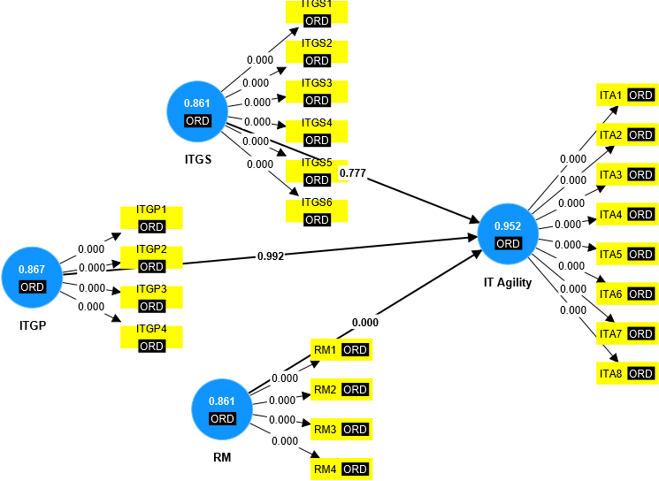
Figure 12: Hypothesis Testing

Table 32- Hypothesis Test Results

Hypothesis No | Hypothesis | Estimates | P-Value | Results
H1 | ITGP -> ITA | 0.008 | 0.992 | Significant relationship doesn’t exist.
H2 | ITGS -> ITA | -0.164 | 0.777 | Significant relationship doesn’t exist.
H3 | RM -> ITA | 0.987 | 0.000 | Accepted.

Hypothesis Testing with Control Variables

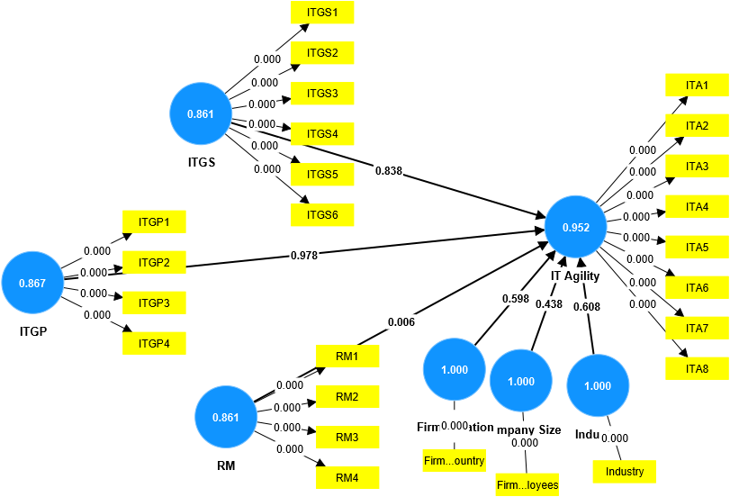
Figure 13: Smart PLS Model with control variables

Although the ANOVA results suggested that the firm size, location, and industry could significantly influence ITGMs, the subsequent analysis using the PLS-SEM revealed that these control variables did not have a significant impact on ITA.

This finding suggests that while certain organizational characteristics may influence the implementation and maturity of ITGMs, they do not directly affect the ITA in responding to market changes and technological advancements. Instead, it appears that the effectiveness of ITGMs, particularly relational mechanisms, plays a more crucial role in determining ITA.

Table 33- Hypothesis Test Results with Control Variables

Relationships | P Values | Estimates | Results
ITGP -> IT Agility | 0.978 | -0.030 | Significant relationship doesn’t exist.
ITGS -> IT Agility | 0.838 | -0.172 | Significant relationship doesn’t exist.
RM -> IT Agility | 0.006 | 1.016 | Accepted.
Firm Location-> ITA | 0.598 | -0.101 | Significant relationship doesn’t exist.
Company Size -> ITA | 0.438 | 0.074 | Significant relationship doesn’t exist.
Industry -> IT Agility | 0.608 | -0.040 | Significant relationship doesn’t exist.

Hypotheses Testing with Location as a Moderator Variable
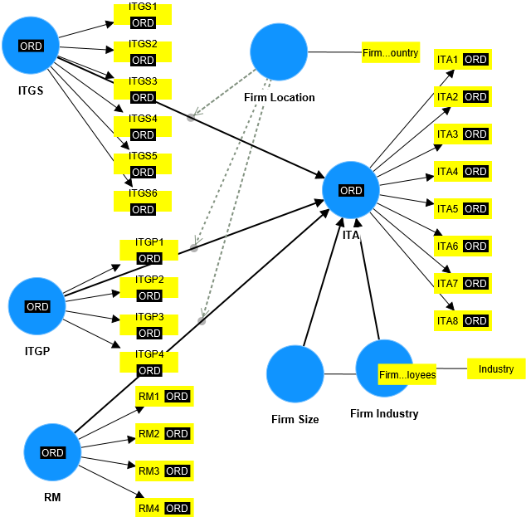
Figure 14: Smart PLS Model with Firm Location as Moderator
The attempt to test the firm location as a moderator variable did not yield significant results, indicating that the firm location does not significantly influence the relationship between ITGMs and ITA.
This finding suggests that regardless of where an organization is located geographically, the impact of ITGMs on ITA remains consistent. Thus, organizations across different regions can focus on similar strategies for enhancing their ITG practices to improve agility in responding to market changes and technological advancements.
While firm location may still play a role in shaping the overall IT landscape and regulatory environment, its direct influence on the relationship between ITG and ITA appears to be limited. Therefore, organizations should prioritize internal factors such as the effectiveness of their ITGMs rather than external factors like geographic location when aiming to improve ITA.
Table 34- Hypothesis Test Results with Location as Moderator Variable

Relationships | P Values | Results
ITGP -> IT Agility | 0.172 | Significant relationship doesn’t exist.
ITGS -> IT Agility | 0.484 | Significant relationship doesn’t exist.
RM -> IT Agility | 0.000 | Accepted.
Firm Location*ITGS -> IT Agility | 0.825 | Significant relationship doesn’t exist.
Firm Location*ITGP-> IT Agility | 0.755 | Significant relationship doesn’t exist.
Firm Location*RM-> IT Agility | 0.664 | Significant relationship doesn’t exist.
Firm Location -> IT Agility | 0.296 | Significant relationship doesn’t exist.
Frim Industry-> IT Agility | 0.986 | Significant relationship doesn’t exist.

Second Round of Focus Group Study
After having covariance-based SEM and PLS-SEM, we asked the participants of the focus group study to provide their professional opinion about the hypothesis testing results by answering questions such as "Do the results make sense to you?" and "Were the results found as you expected?" (See Appendix C). The hypotheses “IT Governance Structure has a positive impact on IT Agility” and “IT Governance Process has a positive impact on IT Agility” were not supported while the hypothesis “Relational Mechanisms have a positive impact on IT Agility.” was supported.
One participant from USA with over 25 years’ experience in IT security in financial industry argues that IT governance structures could have less impact on IT agility.
“The ever-increasing pervasiveness of information technology (IT) has led organizations to heavily rely on it to remain agile in today’s business environment. While the IT governance structure impact on IT agility results is expected, the IT Governance Process impact result is not. Process-based governance improves management's ability to deliver on his business results processes consistently, whereas other aspects may have an arguable lesser impact on IT Agility.”
Another participant from Türkiye with over 20 years’ experience in IT field didn’t agree with the hypothesis 1 and 2 test results and discussed how IT governance process and structure should have an impact on IT agility.
“I do not agree with the results of hypothesis 1. I believe that the IT governance structure plays a crucial role in IT agility. The IT governance structure has a critical effect on determining responsibilities, monitoring, and auditing these responsibilities. For example, if an enterprise has no data privacy monitoring committee, the activities in the GDPR compliance program will not be monitored and the immediate actions will not be taken in time and properly. I do not agree with the results of hypothesis 2. Each company needs a governance system to meet stakeholder expectation and create value from the use of IT. To achieve these targets, we should conduct processes.”
Similarly, another participant from USA who has been working as head of technology risk in a finance company discussed the results of the testing.
“IT Governance enables companies to oversee IT operations and projects, ensuring alignment between these endeavors and the organization's imperative to provide efficient IT systems and services to stakeholders. When organizational goals align with compliance requirements, and IT can address them collaboratively with senior leadership, companies are poised to respond operationally and strategically to external environmental changes more effectively through IT. A key component of the IT Governance process is the creation of a tactical operating plan that aligns with the strategic plan of the organization. This plan ensures the mechanism for how the IT function is measured in terms of supporting and enabling the achievement of the organizational goals to effectively respond operationally and strategically to changes in the market with the use of IT. As a result, the structure and process of IT governance should have a significant impact on IT agility.”
Another participant who has been working in a consulting firm in Türkiye contributed to the results by saying, "It's not strange or unexpected that IT Governance Structure doesn't contribute to IT agility, while an organization running an IT governance process will see a positive contribution to IT agility. Since the IT governance process will contribute to strategy setting, updating, and development-oriented business environments.”
In summary, perhaps the most significant finding was the pronounced impact of relational mechanisms on IT agility. Participants emphasized the critical role of communication and collaboration between IT and business units in facilitating agile responses to market turbulence. Relational mechanisms serve as a vital bridge between IT and business, enabling organizations to sense and respond effectively to changes in their operating environment.

Results of the Semi-Structured Interviews Regarding the Centralization of ITG
The consensus among the respondents in favor of a hybrid ITG model reflects a better understanding of the complexities involved in managing IT services within organizations. While both fully centralized and fully decentralized models have their limitations, the hybrid approach offers a flexible and adaptive solution that can be tailored to meet specific business needs.

The hybrid model acknowledges that different parts of the organization may have unique requirements and preferences when it comes to IT services. By incorporating elements of both centralization and decentralization, organizations can create a balance between standardization and customization, efficiency and autonomy.

Moreover, the hybrid model allows organizations to leverage the strengths of both centralized and decentralized structures while mitigating their respective weaknesses. It provides the flexibility to adapt to changing circumstances, allowing organizations to scale resources up or down as needed and allocate them where they can deliver the most value.

Ultimately, the preference for a hybrid ITG model underscores the importance of agility and flexibility in today’s dynamic business environment. By embracing a hybrid approach, organizations can enjoy the benefits of centralization and decentralization while maximizing their ability to meet the diverse and evolving needs of their stakeholders.

Table 35. Responses to “According to your experiences, which way is the best to provide or get IT services (either fully centralized, fully decentralized, or hybrid based on the needs)?”
R | Responses | Centralized/ Decentralized/Hybrid
R1 | Providing IT services in a fully centralized topology is the best option regarding to my experience. | Centralized
R2 | A hybrid approach to providing IT services is the most effective. While some services can be centralized for standardized and efficient delivery, certain business units or regions may require localized or decentralized IT services to provide to their specific needs and regulations. Finding the right balance between centralization and decentralization ensures agility, flexibility, and responsiveness. | Hybrid
R3 | Fully centralized but a strong IT department is the best way to provide efficient and effective solutions to problems. | Centralized

Table 35 (cont.)
R4 | Getting IT services with fully centralized systems could lead to push business processes to adapt standardized IT Infrastructure. If company had enough sources, fully decentralized systems would be more productive in terms of utilizing IT Infrastructure. | Decentralized
R5 | There is no best way, there is optimum way in IT solutions based on requirements. In that point, hybrid model can be optimum. | Hybrid
R6 | Hybrid based on the needs is the best way. | Hybrid
R7 | It is hybrid based on the needs. Because requirement analysis is important phase to determine whether the service is centralized or hybrid. While it may be centralized if capability is enough in view of knowhow or resource, I strongly believe that it should be hybrid even if capacity is not enough due to any reason or the needs are fully new trend issues. | Hybrid
R8 | Hybrid based IT services may be more efficient and a better way of serving IT services for a company. Centralized IT networks/services may cause a lack of flexibility for the IT employees with respect to fully decentralized ones. Centralized IT services may cause reduction in the costs for the hardware expenses for the company but decrease the flexibility and the freedom of configuration of the IT teams according to their needs and also increases the vulnerability of the systems regarding to have a one central location-based configuration of the systems. It is therefore, a hybrid system providing both cost efficient and a flexible/non-vulnerable may be the most efficient way in my own way of thinking. | Hybrid
R9 | Until now, all of the companies that I worked at have provided IT services by a centralized IT organization. However, I cannot say their IT organizations are fully centralized because in order to satisfy the different units’ needs, different sub-units like financial affairs resolution, supplier relations resolution, project management resolution have been established and been in contact with those units closely. According to my experiences, both satisfying these needs and being agile while doing this requires hybrid IT structures. | Hybrid
R10 | IT management should be structured in a hybrid way. Central IT management I continue to conduct personal visits to determine the company's IT policy and standards, as well as IT services distributed across business units, in accordance with centrally registered policies. | Hybrid

Table 35 (cont.)
R11 | According to my experiences and when advantages and disadvantages of each method is considered hybrid based seems to be the best way. | Hybrid

The insights shared by participants regarding the benefits of centralizing IT services highlight the potential advantages of consolidating IT functions within organizations.
Centralization offers several benefits that can contribute to improved efficiency, cost-effectiveness, and overall organizational performance:

- Sustainability of IT Solutions: Centralizing IT services can promote the sustainability of IT solutions by ensuring consistency, reliability, and continuity in the delivery of IT services across the organization. By centralizing resources and expertise, organizations can establish standardized practices and processes that enhance the stability of IT solutions.

- Cost Reduction: Centralization can lead to cost savings by eliminating redundancies, streamlining processes, and optimizing resource allocation. By consolidating IT resources and infrastructure, organizations can achieve economies of scale and reduce overhead costs associated with managing multiple decentralized IT units.

- Economies of Scale: Centralizing IT services enables organizations to leverage economies of scale by pooling resources, sharing infrastructure, and negotiating bulk discounts with vendors. This allows organizations to achieve greater purchasing power and cost efficiencies, ultimately resulting in lower overall IT expenditures.

- Operational Efficiencies: Centralization promote operational efficiencies by centralizing decision-making authority, standardizing processes, and promoting collaboration and coordination among IT teams. This streamlines workflows, reduces duplication of efforts, and enhances productivity across the organization.

- Common Solutions to IT Problems: Centralizing IT services facilitates the development and implementation of common solutions to IT problems. By standardizing IT policies, applications, and processes, organizations can address common challenges more effectively and efficiently, minimizing the need for ad-hoc solutions and troubleshooting.

- Standardization in IT Policies, Applications, and Processes: Centralization promotes standardization in IT policies, applications, and processes, ensuring consistency and uniformity in the delivery of IT services. This simplifies IT management and maintenance, reduces complexity, and enhances overall system reliability and performance.

- Ease of Management of IT Applications: Centralization simplifies the management of IT applications by consolidating resources, centralizing control, and standardizing processes. This allows organizations to more effectively monitor, maintain, and support IT applications, resulting in improved system reliability, security, and performance.

To sum up, the benefits of centralizing IT services underscore its potential to enhance organizational efficiency, reduce costs, and improve the quality and reliability of IT solutions. By centralizing IT functions, organizations can streamline operations, achieve economies of scale, and better align IT resources with business objectives, ultimately driving greater value and competitive advantage.
Moreover, centralizing ITG can contribute to economies of scale through the consolidation of IT application and infrastructure procurement, enhanced utilization of IT resources, standardization of IT processes and procedures, allocation of specialized IT personnel to designated projects, and reduction of training expenses.
Table 36. Responses to “Regarding your experiences, what is the most significant benefit of centralizing IT services?”
Respondents | Responses | Benefits
R1 | The sustainability of solutions, ensuring compliance with company standards, and information security. | Sustainability of IT solutions
R2 | Reducing expenses (data center, hardware, software, personnel, energy, time and operational costs) seems to be the most significant benefit of centralizing IT services. | Reducing expenses
R3 | The most significant benefit of centralizing IT services is the ability to achieve economies of scale and operational efficiencies. By consolidating resources, technologies, and expertise, organizations can streamline processes, reduce costs, enhance service quality, and improve consistency across the entire IT landscape. | Achieving economies of scale and operational efficiencies
R4 | Central IT department provides common solutions to problems which at the end is easier to manage and have a standard way of working. | Common solutions to problems

Table 36 (cont.)
R5 | It would reduce the software development cost and purchasing IT hardware. | Reducing IT costs
R6 | First advantage is always standardization in tools, applications and reports and also other dominant advantage is cost optimizations. | Standardization in IT applications, cost optimization
R7 | Cost efficiency and standardization of processes are the most significant benefit. | Standardization of processes, cost efficiency
R8 | I think it is the ease of management and support based on visibility. | Ease of management of IT applications
R9 | Reducing the costs of hardware expenses, office and administrative costs. | Reducing IT costs
R10 | Centralized IT structures can be more standardized; thus, it will be easy to manage provided services and achieve a consistent quality. | Standardization to support quality
R11 | I believe that the implementation of basic policies and standards will be easier, good practices determined by feedback from sub-teams will be easily disseminated, efficiency in software license management and use will increase, and corporate cyber security studies can be implemented more easily by centralized IT management. | Standardization of IT policies and standards

The insights shared by the participants regarding the drawbacks of centralizing IT services highlight the potential challenges and limitations associated with this approach. These drawbacks can have significant implications for organizational performance, agility, and competitiveness:

- Struggling to Fulfill Expectations: Centralizing IT services may lead to challenges in meeting stakeholders' expectations, particularly if centralized solutions fail to adequately address the unique needs and requirements of different business units or departments.

- Speed Requirements: Centralization can impede an organization's ability to respond quickly to evolving business needs and market dynamics, particularly if decision-making processes become bureaucratic or hindered by centralized control.

- Organizational Structure Conflicts: Centralizing IT services may create conflicts within the organizational structure, particularly if centralized decision-making processes conflict with departmental autonomy or business unit objectives.

- Lack of Qualified IT Personnel: Centralization may result in a concentration of IT resources and expertise in centralized teams, leading to a shortage of qualified IT personnel in other areas of the organization. This can hinder an organization's ability to effectively support IT initiatives and projects across the enterprise.

- Limiting Flexibility and Agility: Centralization may limit an organization's flexibility and agility in responding to unique business requirements or emerging opportunities. A centralized approach may be less adaptable to change and innovation, particularly if decision-making processes are rigid or hierarchical.

- Emergence of Shadow IT: Centralization may inadvertently encourage the emergence of shadow IT, where departments or business units bypass centralized IT services to procure or develop their own IT solutions. This can lead to issues related to security, compliance, and integration.

- Forcing Business Process Standardization: Centralization may force business processes to adopt standardized practices and procedures, potentially hinder innovation and creativity within individual departments or business units.

- Slow Reaction Time to IT Issues: Centralization may result in slower reaction times to IT issues or problems, particularly if decision-making processes are centralized and bureaucratic.

- Loss of Control Over IT Infrastructures: Centralization may lead to a loss of control over an organization's IT infrastructure and applications, particularly if decision-making authority is concentrated in a centralized IT department or team.

- Increasing Vulnerability of the System: Centralization may increase the vulnerability of an organization's IT systems and infrastructure to security breaches, cyberattacks, or other threats, particularly if centralized systems become targets for malicious actors.

- Inefficient Processes and Unsatisfied Internal Customers: Centralization may result in inefficient processes and workflows, leading to dissatisfaction among internal customers and stakeholders who rely on IT services for their day-to-day operations.

- Hindering Agile Digital Transformation: Centralization may hinder an organization's ability to embrace agile digital transformation initiatives, particularly if centralized control or bureaucracy impedes the adoption of innovative technologies and practices.

Overall, the drawbacks of centralizing IT services underscore the importance of carefully balancing centralized control with decentralized autonomy to effectively meet the diverse needs and requirements of the organization. By addressing these challenges proactively, organizations can optimize their ITG strategies and maximize the value of their IT investments.

Table 37. Responses to “Regarding your experiences, what is the biggest problem of centralizing IT services?”
Respondents | Responses | Problems
R1 | Today, the expectations from IT, IT demands, the impact of IT on business and its potential to add value have possibly reached the highest level to date. We are experiencing this in an environment where IT is mostly centralized. When we look at the outcomes of this intense demand and centralized IT environment, a study conducted among Gartner members reveals that speed to complete initiatives are 59% behind expectations, and speed to realize value is 52% behind expectations. Therefore, we can say that strictly centralized IT structures are struggling to fulfill the expectations and meet the speed requirements of the day. | Struggling to fulfill the expectations and meet the speed requirements
R2 | Organizational structure conflicts, lack of qualified IT personnel, need for IT budget seems to be the problems of centralizing IT services. | Organizational structure conflicts, lack of qualified IT personnel
R3 | One of the challenges of centralizing IT services is striking the right balance between standardization and customization. While centralization promotes consistency and cost savings, it may limit the flexibility and agility needed to address unique business requirements or local regulations. Finding the optimal balance is crucial to avoid hindering business operations or innovation. | Limiting the flexibility and agility needed to address unique business requirements

Table 37 (cont.)
R4 | When the company is too big for the IT department to handle (a weak IT department), then each department tends to solve their own problem regardless of a central IT. That means, shadow IT’s start to appear in the organization which is the biggest problem of centralized IT. | Emerging of shadow IT
R5 | In some cases, it forces processes to adapt to the central IT Infrastructure such as software and hardware. | Forcing business process to adopt standardization
R6 | Slow reaction time to solve problems could occur. | Slow reaction time to IT issues
R7 | Speed of problem solving is the biggest problem. | Low speed of problem solving
R8 | It could lead to lose of control. If the centralized IT support team is unable to resolve an issue, it can lead to a loss of control over the enterprise's IT infrastructure and applications. | Loss of control over the enterprise's IT infrastructure and applications
R9 | Increasing the vulnerability of the system regarding the failures, accidents regarding the one and only central location-based hardware, servers and etc. | Increasing the vulnerability of the system
R10 | Easy management and consistent quality can be seen as an advantage at first, however attaining efficiency and internal customer satisfaction is beyond this. Centralizing IT services and being strict about that could lead to inefficient processes and unsatisfied internal customers. | Inefficient processes and unsatisfied internal customers
R11 | I estimate that the biggest problem that will arise would be bulkiness. This situation can hinder today's agile digital transformation. | Hindering today's agile digital transformation

CHAPTER 5

DISCUSSION AND CONCLUSION
  - Discussion
The goal of this study was to understand the impact of ITGMs on ITA. The results showed that relational ITGMs have a significant impact on ITA. However, the more basic aspects of ITG, such as structures and processes, are not significant. A further interpretation could be done as given below.

Relational ITG includes mechanisms such as support for the IT function to collaborate with business units across a firm, i.e. top management supports an active and regular interplay between business and IT. This is often instantiated and sustained by cross-functional training, and a clear articulation by the leadership of the role of IT within a firm. These relational mechanisms can lead to a shared understanding of the corporate objectives. All of this could mean that it is the achievement of mutual understanding through ITG that influences ITA more so than structures and processes. In other words, agility is achieved when IT is tightly integrated with a business, and if you have management buy-in and support, the rest works itself out.

One interpretation of the finding is that structures and processes tend to be formal and often required. Hence, employees may accept these mechanisms as important for compliance and ITG but without the addition of specific relational mechanisms, they may not achieve agility. The coefficient for ITGSs was positive, implying that mechanisms such as an IT strategy committee, steering committee, and the integration of governance and alignment task might have an enabling effect on agility, while the coefficient for ITG processes was negative, suggesting that mechanisms such as formal planning, governance frameworks, and performance measures might inhibit agility. However, they are so far from being significant that it is hard to draw any kind of meaningful interpretation.

Moreover, it cannot be concluded that these more formal mechanisms inhibit agility even though that may be how they are perceived by key employees. Furthermore, given the very high R-square of the overall model, it is likely that relational mechanisms are the most important mechanism. However, it will be important for future research to investigate how governance structures and processes enable and inhibit agility. It is not as if organizations have the choice to stop implementing ITG structures and processes. What is important is that the one governance mechanism that some organizations may see as more voluntary, is the one that turns out to be the most important for enabling ITA – IT relational mechanisms. This is an important practical implication for organizations and IT leaders such as CIOs, i.e., relational governance mechanisms generate positive externalities beyond their specific purpose.

The above implications were also confirmed by the post-hoc analysis involving the original group of focus group participants. This analysis was informal, in that the results were shared with the group, and they were asked for their feedback as a “reality check.” Only 3 responses were received, but their reactions were interesting. First, none of the 3 were surprised by the importance of IT relational mechanisms. Reacting to the non-significant role of structure and process: One said, “It is not strange or unexpected that ITGS does not contribute to ITA, while an organization running an ITG process will see a positive contribution to ITA.” Another person contradicted the above by noting “I believe that the ITGS plays a crucial role in ITA. Without a proper designed structured, the information that will be used in decision making processes will be not shared between business units or critical stakeholders. And this will impact the timely decision making and governance of IT.” However, although there was disagreement about the role of structure among the 3 practitioners, they did insist that processes were important in enabling agility. Therefore, as noted above, it will be important for future research to unravel how and when structure and process play a role.

Another potential interpretation of the results is to consider the maturity of the organizations. Specifically, given the multi-country nature of this study, it is possible that regions that are more or less mature in implementing ITGMs may enable or inhibit ITA differentially. The analysis did not show a statistically significant difference between respondents in Türkiye vs. the USA. However, only the governance mechanisms in aggregate were analyzed, i.e. all of the mechanisms relating to structure were grouped together and likewise for processes and relational mechanisms. Furthermore, all of the items related to ITA were grouped together.

It is possible that the governance mechanisms and ITA items relate differently when analyzed individually in the context of maturity (of regions or other dimensions). For example, it seems intuitive that a more mature IT organization will have evolved over time a robust yet flexible implementation of structures such as aligning roles and tasks, or the use of process measures such as scorecards. This could be another important area of research.

Moreover, as businesses process dependency on ISs, their organizations’ concern about how to place ITG functions arise. The centralization and decentralization of ITG have been widely discussed in the ITG literature since the beginning of the use of computers. As organizations began to operate their business functions across the world, the discussion on how to meet business technological needs emerged in terms of placing IT decision-making functions throughout their organizations.

To explore the optimum solution to centralization or decentralization ITG functions, the papers that focused on the concepts of centralization and ITG were analyzed. Recent studies have shown that the third approach to the centralization discussion emerged as a federal or hybrid solution.

In the current study, an interview series was conducted in a large technology firm that has complex IT projects and infrastructure. The interviewees have plenty of knowledge about ITG and 10+ years of working experience in various departments such as IT, manufacturing and digitalization departments.

Based on the interview results, it was concluded that the hybrid ITG model could be the best solution to meet business units’ needs as it does not involve the centralization of whole IT functions. As the interviewees discussed centralizing IT services, they suggested that this approach would provide sustainability of IT solutions, reducing cost of IT investments, achieving economies of scale and operational efficiencies, common solutions to IT problems, standardization in IT policies, applications and processes, and ease of management of IT applications. Consequently, the interviewees introduced the drawbacks of centralizing IT services as struggling to fulfill expectations, meeting the speed requirements, organizational structure conflicts, a lack of qualified IT personnel, limiting the flexibility and agility needed to address unique business requirements, emergence of shadow IT, forcing business process to adopt standardization, slow reaction time to IT issues and low speed of problem solving, loss of control over the enterprise’s IT infrastructure and applications, increasing the vulnerability of the system, inefficient processes and unsatisfied internal customers, and hindering today’s agile digital transformation. During the discussion of centralization of ITG functions, it was mentioned that IT quality and response time have the highest importance over usefulness, accessibility, and ease of use.

For future studies, it is suggested to conduct research on which ITG functions should be centralized or decentralized by considering IT concerns that have been discussed in this study.

    - Impact of the ITGS on ITA
To speak of each component of ITGMs separately, it could be said that the ITGS has no significant impact on ITA; however, if the ITG process could have reached at a more mature level , it could potentially improve organizations’ reactions to industry changes, as can be seen Section 5.2.3.
The ITGS should not be limited to having IT committees in senior management, but also the mindset of implementing digitalization to business processes in upper management should be in the upper management table. Having said that, business processes are relying on ITs increasingly; thus, business processes cannot be evaluated without understanding the requirements of IT.

    - Impact of ITG Processes on ITA
The lack of a significant impact of ITG processes on ITA, particularly in cases where the maturity level of IT processes is low, underscores the importance of adhering to established ITG frameworks and standards. When organizations fail to follow these frameworks and standards, they may fail to respond effectively to industry changes.
By implementing recognized ITG frameworks such as COBIT, ITIL, and utilizing IT performance measurement tools, organizations can establish a proactive approach to managing their IT processes. These frameworks provide a structured methodology for managing IT operations, ensuring alignment with business objectives, and optimizing IT resources to enhance agility.
Furthermore, adherence to ITG standards can improve a mindset among professionals that prioritizes compliance, efficiency, and continuous improvement. By embracing these standards and integrating them into their IT processes, organizations can better anticipate and respond to industry changes, positioning themselves for sustained success in today’s dynamic business landscape.
    - Impact of Relational Mechanisms on ITA
This study has shown that relational mechanisms between IT and business could potentially have an impact on ITA, which means that organizations should strengthen the bridge and communications between process owners and technology providers in their organizations.
Herein, cross-functional training between business and IT, top management support for business and IT collaboration, and a shared understanding of business objectives were discussed. However, other ways to strengthen the relationship between process owners and IT could be considered. Companies should seek a better understanding on both sides and improve knowledge sharing platforms to create a smooth connection. Without understanding business objectives and strategies, IT investment would not create business value.
    - Comparing the Results with the Existing Literature
Even though there are no studies that have focused on the direct relationship between ITGMs and ITA, there have been a few attempts that have explored the impact that ITGMs have on organization agility with some mediator and moderator variables. Elazhary et al. (2022) studied how ITG influences organizational agility with an understanding of IT capability. They obtained results similar to those in the current study, as their results showed the strong impact of ITGMs on organizational agility when facing changing market conditions.
A similar approach was taken by Zhen et al. (2021) in their study, where they investigated the influence of ITGMs on organizational agility, considering the effects of IT exploration and exploitation. Based on their research, it was found that process-based and relational governance have a significant impact on IT exploration and exploitation, and consequently, on organizational agility. Whereas structural governance had no significant impact on organizational agility. The only contradiction between their study and the current one is that the significant impact of process-based governance on agility was not found herein.
  - Conclusion
In conclusion, this study investigated the relationship between ITGMs and ITA, aiming to provide insights into how organizations can effectively govern their IT functions to enhance agility in responding to environmental changes and new opportunities. Through a comprehensive examination of ITGMs, including structure, process, and relational aspects, it was sought to explain their impact on ITA.

The findings revealed that while formal ITG structures and processes may not significantly influence ITA, relational mechanisms that facilitate collaboration and communication between business and IT play a pivotal role in fostering agility. Strengthening the bridge between business and IT, along with establishing IT knowledge among upper management, emerged as key factors in enhancing ITA, particularly in organizations with well-established IT processes.

Furthermore, this study highlighted the importance of considering hybrid ITG models, which strike a balance between centralization and decentralization, to meet the diverse needs of business units. While centralizing IT services may offer benefits such as cost reduction and standardization, it also presents challenges such as organizational conflicts and reduced flexibility. Hence, organizations must carefully weigh the pros and cons of centralization and adopt a hybrid approach that addresses unique business requirements while fostering agility.

Moving forward, future research should focus on identifying specific ITG functions that are best suited for centralization or decentralization, considering the insights gleaned from this study. By addressing these gaps in the literature, researchers can further enhance our understanding of ITG and its implications for organizational agility in an increasingly digitalized world. Ultimately, the findings from such studies can provide practical strategies for organizations seeking to optimize their ITG practices and improve their agility in an evolving business landscape.

  - Contribution of the Study
The contribution of this study was to explore the impact of ITG on ITA – both of which are critical topics for most firms. Key constructs for ITGMs were identified and measured from the literature, and how the research question could be empirically investigated was shown. The important future questions were identified, such as how mature IT organizations can evolve. For practice, it was shown that IT relational mechanisms were critical in ensuring that ITGMs positively influence ITA.

    - Implication for Researchers
This study introduces a novel approach to investigating the relationship between ITGMs and ITA in the context of the limited existing literature on ISs. By combining focus group study and survey methodologies, the research design offers a robust framework for exploring this important phenomenon. This innovative approach not only addresses the gap in the literature but also provides a comprehensive understanding of the complex dynamics between ITG and ITA.
Furthermore, the study demonstrates the application of CB-SEM and PLS-SEM methodologies to analyze new phenomena in the field. Through a detailed discussion, the research elucidated the process of incorporating descriptive variables such as the firm size, location, and industry into the research model. This methodological contribution enhanced the rigor and validity of the study’s findings, providing a roadmap for future researchers seeking to explore similar topics.
Moreover, the study contributes to the theoretical understanding of ITGMs by conceptualizing these constructs based on an extensive literature review. By identifying key components and relationships within ITGMs, the research lays the foundation for empirical investigation into their impact on ITA. This theoretical framework not only advances scholarly discourse but also offers practical insights for organizations striving to enhance their ITG practices and agility in an increasingly digitalized world.
Overall, this study represents a significant contribution to the field of ISs by introducing innovative research methodologies, applying advanced statistical techniques, and advancing theoretical knowledge in the domain of ITG and ITA. By addressing critical gaps in the literature and providing actionable insights, the study offers valuable implications for both academia and practice.
    - Implication for IT Professionals
Indeed, the significance of fostering collaboration between IT and business departments cannot be overstated. A key aspect highlighted in this study is the importance of establishing a strong bridge between IT and business functions within organizations. This bridge serves as the road through which strategic alignment, mutual understanding, and effective communication between IT and business units can occur.
Central to this collaboration is the endorsement and support of top management. When senior leadership actively promotes and champions cross-functional collaboration, it sets the tone for organizational culture and encourages a mindset of integration between IT and business objectives. This endorsement ensures that both IT and business units work together towards common goals and objectives, leveraging technology to drive business strategy and market positioning.
Furthermore, effective IT leadership plays a pivotal role in facilitating this collaboration. IT leaders are tasked with not only managing technology initiatives but also with aligning IT efforts with broader business strategies. By assuming a leadership role in fostering cross-functionality and promoting a shared understanding of business objectives, IT leaders can help bridge the gap between IT capabilities and business needs.
Ultimately, the success of IT-business collaboration hinges on establishing a culture of mutual respect, open communication, and shared accountability. When IT and business units work together seamlessly, organizations can harness the full potential of technology to drive innovation, agility, and competitive advantage in the marketplace.
  - Limitations of the Study and Recommendations for Future Research
While this study provides valuable insights into the relationship between ITGMs and ITA, there were several limitations that support consideration and present opportunities for future research.
- Limited Scope of ITGMs: The focus of this study was on a specific set of 14 ITGMs identified through the focus group study. Future research could explore additional or alternative components of ITGMs to provide a more comprehensive understanding of their impact on ITA.
- Geographical Scope: This study primarily focused on IT professionals from Türkiye and the USA. However, differences in regulations, organizational culture, and industry practices across different regions may influence the relationship between ITGMs and ITA. Future research could expand the geographical scope to include organizations from diverse regions such as Europe, Asia, and other continents to provide a more globally representative perspective.
- Methodological Considerations: This study employed both qualitative (focus group) and quantitative (survey) research methods to investigate the research questions. While this approach offers robust insights, alternative research methodologies or mixed-method approaches could be explored in future studies.
- Small Sample Size: For the discussion on centralization of ITG, the study relied on a limited number of senior experts, comprising only 11 participants. While these individuals possess significant knowledge and experience in ITG, the small sample size may limit the generalizability of the findings to broader organizational contexts. Future research could benefit from larger and more diverse samples to ensure greater representativeness and reliability of the results.
In conclusion, addressing these limitations and conducting further research in these areas could provide deeper insights into the dynamics of ITG and its implications for organizational agility, ultimately contributing to more effective IT management practices and strategic decision-making.

REFERENCES
Aasi, P., Rusu, L., & Han, S. (2014). Culture Influence on IT Governance. International Journal of IT/Business Alignment and Governance, 5(1), 34–49. https://doi.org/10.4018/IJITBAG.2014010103
Adams, C., Larson, E., & Xia, W. (2007). A trend toward more centralized information technology (IT) management.
Ali, S., & Green, P. (2012). Effective information technology (IT) governance mechanisms: An IT outsourcing perspective. Information Systems Frontiers, 14(2), 179–193. https://doi.org/10.1007/S10796-009-9183-Y
Belanger, F. (2012). Theorizing in information systems research using focus groups. Australasian Journal of Information Systems, 17(2), 109–135. https://doi.org/10.3127/AJIS.V17I2.695
Bianchi, I. S., Sousa, R. D., Pereira, R., & Luciano, E. (2017). IT governance structures in Brazilian, Dutch and Portuguese universities. Procedia Computer Science, 121, 927-933.
Bloomfield, B. P., & Coombs, R. (1992). Information technology, control and power: The centralization and decentralization debate revisited. Journal of management studies, 29(4), 459-459.
Brown, A. E., & Grant, G. G. (2005). Framing the frameworks: A review of IT governance research. Communications of the Association for Information Systems, 15(1), 38.
Byrd, T. A., & Turner, D. E. (2000). Measuring the flexibility of information technology infrastructure: Exploratory analysis of a construct. Journal of Management Information Systems, 17(1), 167–208. https://doi.org/10.1080/07421222.2000.11045632
Chong, J. L. L., & Tan, F. B. (2012). IT Governance in Collaborative Networks: A Socio-Technical Perspective. Pacific Asia Journal of the Association for Information Systems, 31–48. https://doi.org/10.17705/1PAIS.04202
Couto, E. S., Lopes, M. F. C., & Sousa, R. D. (2015). Can IS/IT Governance Contribute for Business Agility? Procedia Computer Science, 64, 1099–1106. https://doi.org/10.1016/J.PROCS.2015.08.565
Cragg, P., King, M., & Hussin, H. (2002). IT alignment and firm performance in small manufacturing firms. Journal of Strategic Information Systems, 11(2), 109–132. https://doi.org/10.1016/S0963-8687(02)00007-0
da Silva, H. C. C., Dornelas, J. S., & Araújo, M. A. V. (2022). Strategic role of IT and IT governance mechanisms for the context of small and medium enterprises. REGEPE Entrepreneurship and Small Business Journal, 11(1), e2051-e2051.
Damianides, M. (2005). Sarbanes–Oxley and it governance: New guidance on it control and compliance. Information Systems Management, 22(1), 77–85. https://doi.org/10.1201/1078/44912.22.1.20051201/85741.9
de Haes, S., Huygh, T., Joshi, A., & van Grembergen, W. (2016). Adoption and Impact of IT Governance and Management Practices. International Journal of IT/Business Alignment and Governance, 7(1), 50–72. https://doi.org/10.4018/IJITBAG.2016010104
de Haes, S., & van Grembergen, W. (2005). IT governance structures, processes and relational mechanisms: Achieving IT/business alignment in a major Belgian financial group. Proceedings of the Annual Hawaii International Conference on System Sciences, 237. https://doi.org/10.1109/HICSS.2005.362
de Haes, S., & van Grembergen, W. (2009). An Exploratory Study into IT Governance Implementations and its Impact on Business/IT Alignment. Information Systems Management, 26(2), 123–137. https://doi.org/10.1080/10580530902794786
de Haes, S., & van Grembergen, W. (2015). Enterprise Governance of IT (pp. 11–43). Springer International Publishing. https://doi.org/10.1007/978-3-319-14547-1_2
Dove, R., & Palmer, L. M. (2004). Response Ability: The Language, Structure, and Culture of the Agile Organization. INSIGHT, 6(2), 41–41. https://doi.org/10.1002/INST.20046241
Elazhary, M., Popovič, A., Henrique de Souza Bermejo, P., & Oliveira, T. (2022). How information technology governance influences organizational agility: the role of market turbulence. Information Systems Management, 1-21.
Feeny, D. F., & Willcocks Sloan, L. P. (1998). Core IS capabilities for exploiting information technology. Management Review; Spring, 39, 3.
Ferguson, C., Green, P., Vaswani, R., & Wu, G. (2013). Determinants of Effective Information Technology Governance. International Journal of Auditing, 17(1), 75–99. https://doi.org/10.1111/J.1099-1123.2012.00458.X
Fink, L., & Neumann, S. (2007). Gaining agility through IT personnel capabilities: The mediating role of IT infrastructure capabilities. Journal of the Association for Information Systems, 8(8), 440–462. https://doi.org/10.17705/1JAIS.00135
Golden, W., & Powell, P. (2000). Towards a definition of flexibility: in search of the Holy Grail? Omega, 28(4), 373–384. https://doi.org/10.1016/S0305-0483(99)00057-2
Hair, J. F., Black, W. C., Babin, B. J., & Anderson, R. E. (2014). Multivariate Data Analysis: Pearson New International Edition Seventh edition. Pearson Education Limited.
Hancock, G. R., & Mueller, R. O. (2013). Structural Equation Modeling. In G. R. Hancock & R. O. Mueller (Eds.), Quantitative methods in education and the behavioral sciences. Issues, research, and teaching. Information Age Publishing, Incorporated.
Hardy, G. (2006). Using IT governance and COBIT to deliver value with IT and respond to legal, regulatory and compliance challenges. Information Security Technical Report, 11(1), 55–61. https://doi.org/10.1016/J.ISTR.2005.12.004
Henderson, J. C., & Venkatraman, N. (1999). Strategic alignment: leveraging information technology for transforming organizations. IBM Systems Journal, 38(2), 472–484. https://doi.org/10.1147/SJ.1999.5387096
Héroux, S., & Fortin, A. (2014). Exploring IT Dependence and IT Governance. Information Systems Management, 31(2), 143–166. https://doi.org/10.1080/10580530.2014.890440
Hooper, M. J., Steeple, D., & Winters, C. N. (2001). Costing customer value: an approach for the agile enterprise. International Journal of Operations & Production Management, 21(6), 144–3577. http://www.emerald-library.com/ft
ITGI. (2003). Board Briefing for IT Governance (2nd ed.). Information Systems Audit and Control Association.
Jafarijoo, M., & Joshi, K. D. (2024). The Interplay of IT Governance Mechanisms, Value and Performance: The Case of Cloud Computing Investment.
Joshi, A., Bollen, L., & Hassink, H. (2013). An Empirical Assessment of IT Governance Transparency: Evidence from Commercial Banking. Information Systems Management, 30(2), 116–136. https://doi.org/10.1080/10580530.2013.773805
Khalil, S., & Belitski, M. (2020). Dynamic capabilities for firm performance under the information technology governance framework. European Business Review, 32(2), 129–157. https://doi.org/10.1108/EBR-05-2018-0102/FULL/PDF
Klein, E. E., Tellefsen, T., & Herskovitz, P. J. (2007). The use of group support systems in focus groups: Information technology meets qualitative research. Computers in Human Behavior, 23(5), 2113–2132. https://doi.org/10.1016/J.CHB.2006.02.007
Lee, O. K., Sambamurthy, V., Lim, K. H., & Wei, K. K. (2015). How does IT ambidexterity impact organizational agility? In Information systems research (Vol. 26, Issue 2, pp. 398–417). INFORMS Inst.for Operations Res.and the Management Sciences. https://doi.org/10.1287%2Fisre.2015.0577
Leonhardt, D., Haffke, I., Kranz, J., & Benlian, A. (2017). Reinventing the IT function: The Role of IT Agility and IT Ambidexterity in Supporting Digital Business Transformation. Proceedings of the 25th European Conference on Information Systems (ECIS), Guimarães (Portugal), June 8-10, 2017, 968–984. https://aisel.aisnet.org/ecis2017_rp/63
Liu, C. W., Huang, P., & Lucas Jr, H. C. (2020). Centralized IT decision making and cybersecurity breaches: Evidence from US higher education institutions. Journal of Management Information Systems, 37(3), 758-787.
Lowry, P. B., & Wilson, D. (2016). Creating agile organizations through IT: The influence of internal IT service perceptions on IT service quality and IT agility. Journal of Strategic Information Systems, 25(3), 211–226. https://doi.org/10.1016/J.JSIS.2016.05.002
Lu, Y., & Ramamurthy, K. (2011). Understanding the link between information technology capability and organizational agility: An empirical examination. MIS Quarterly: Management Information Systems, 35(4), 931–954. https://doi.org/10.2307/41409967
Lunardi, G. L., Becker, J. L., Maçada, A. C. G., & Dolci, P. C. (2014). The impact of adopting IT governance on financial performance: An empirical analysis among Brazilian firms. International Journal of Accounting Information Systems, 15(1), 66–81. https://doi.org/10.1016/J.ACCINF.2013.02.001
Magnusson, J. (2013). Intentional decentralization and instinctive centralization: a revelatory case study of the ideographic organization of it. Information Resources Management Journal (IRMJ), 26(4), 1-17.
Mao, H., Liu, S., Zhang, J., Zhang, Y., & Gong, Y. (2021). Information technology competency and organizational agility: roles of absorptive capacity and information intensity. In Information technology & people (West Linn, Or.) (Vol. 34, Issue 1, pp. 421–451). Emerald Group Holdings Ltd. https://doi.org/10.1108%2FITP-12-2018-0560
Mathiassen, L., & Pries-Heje, J. (2006). Business agility and diffusion of information technology. European Journal of Information Systems, 15(2), 116–119. https://doi.org/10.1057/PALGRAVE.EJIS.3000610
Mergel, I. (2019). Digital service teams in government. Government Information Quarterly, 36(4), 101389.
Nfuka, E. N., & Rusu, L. (2011). The effect of critical success factors on IT governance performance. Industrial Management and Data Systems, 111(9), 1418–1448. https://doi.org/10.1108/02635571111182773/FULL/PDF
Overby, E., Bharadwaj, A., & Sambamurthy, V. (2006). Enterprise agility and the enabling role of information technology. European Journal of Information Systems, 15(2), 120–131. https://doi.org/10.1057/PALGRAVE.EJIS.3000600
Panda, S., & Rath, S. K. (2017). The effect of human IT capability on organizational agility: an empirical analysis. Management Research Review, 40(7), 800–820. https://doi.org/10.1108/MRR-07-2016-0172/FULL/PDF
Peterson, R. (2004). Crafting information technology governance. Information Systems Management, 21(4), 7–22. https://doi.org/10.1201/1078/44705.21.4.20040901/84183.2
Prasad, A., Heales, J., Green, P., Prasad, A. ;, & Heales, J. ; (2009). Towards a Deeper Understanding of Information Technology Governance Effectiveness: A Capabilities-Based Approach. http://aisel.aisnet.org/icis2009/122
Roberts, N., & Grover, V. (2012). Investigating firm’s customer agility and firm performance: The importance of aligning sense and respond capabilities. Journal of Business Research, 65(5), 579–585. https://doi.org/10.1016/J.JBUSRES.2011.02.009
Sambamurthy, V., & Zmud, R. W. (1999). Arrangements for information technology governance: A theory of multiple contingencies. MIS quarterly, 261-290.
Sambamurthy, V., Bharadwaj, A., & Grover, V. (2003). Shaping agility through digital options: Reconceptualizing the role of information technology in contemporary firms. MIS Quarterly: Management Information Systems, 27(2), 237–264. https://doi.org/10.2307/30036530
Sarstedt, M., Ringle, C. M., & Hair, J. F. (2022). Partial Least Squares Structural Equation Modeling. Handbook of Market Research, 587–632. https://doi.org/10.1007/978-3-319-57413-4_15
Schlosser, F., Beimborn, D., Weitzel, T., & Wagner, H. T. (2015). Achieving social alignment between business and IT - An empirical evaluation of the efficacy of IT governance mechanisms. Journal of Information Technology, 30(2), 119–135. https://doi.org/10.1057/JIT.2015.2
Schwarz, A., & Hirschheim, R. (2003). An extended platform logic perspective of IT governance: managing perceptions and activities of IT. The journal of strategic information systems, 12(2), 129-166.
Sharifi, H., & Zhang, Z. (2001). Agile manufacturing in practice Application of a methodology. International Journal of Operations & Production Management, 21(6), 144–3577. http://www.emerald-library.com/ft
Smits, D., & Hillegersberg, J. van. (2015). IT Governance Maturity: Developing a Maturity Model Using the Delphi Method. 2015 48th Hawaii International Conference on System Sciences. https://ieeexplore.ieee.org/document/7070361/
Smits, D., & van Hillegersberg, J. (2017). The development of a hard and soft IT governance assessment instrument. Procedia Computer Science, 121, 47–54. https://doi.org/10.1016/J.PROCS.2017.11.008
Sobreperez, A., & Sobreperez, P. (2008). Title Using plenary focus groups in information systems research: More than a collection of interviews USING PLENARY FOCUS GROUPS IN INFORMATION SYSTEMS RESEARCH: MORE THAN A COLLECTION OF INTERVIEWS. The Electronic Journal of Business Research Methods, 6, 181–188. http://usir.salford.ac.uk/id/eprint/2268/www.ejbrm.com
Sushil, & Chroust, G. (2015). Systemic Flexibility and Business Agility. Springer India.
Tallon, P. P., & Pinsonneault, A. (2011). Competing perspectives on the link between strategic information technology alignment and organizational agility: Insights from a mediation model. MIS Quarterly: Management Information Systems, 35(2), 463–486. https://doi.org/10.2307/23044052
Tanriverdi, H. (2006). Performance effects of information technology synergies in multibusiness firms. MIS quarterly, 57-77.
Teece, D. J. (2007). Explicating dynamic capabilities: the nature and microfoundations of (sustainable) enterprise performance. Strategic Management Journal, 28(13), 1319–1350. https://doi.org/10.1002/SMJ.640
Turel, O., & Bart, C. (2014). Board-level IT governance and organizational performance. European Journal of Information Systems, 23(2), 223–239. https://doi.org/10.1057/EJIS.2012.61
Ullman, J. B., & Bentler, P. M. (2012). Structural Equation Modeling. Handbook of Psychology, Second Edition. https://doi.org/10.1002/9781118133880.HOP202023
Urbach, N., Theory, F. A.-J. of I. T., & 2010, undefined. (2010). Structural equation modeling in information systems research using partial least squares. Aisel.Aisnet.Org, 167(2), 5–40. https://aisel.aisnet.org/jitta/vol11/iss2/2/
van der Heijden, H. (2001). Measuring IT core capabilities for electronic commerce. Journal of Information Technology, 16(1), 13–22. https://doi.org/10.1080/02683960010028447
van Grembergen, W., & DeHaes, Steven. (2008). Implementing Information Technology Governance: Models, Practices, and Cases. In Implementing Information Technology Governance: Models, Practices, and Cases. IGI Global (701 E. Chocolate Avenue, Hershey, Pennsylvania, 17033, USA).
van Grembergen, W., Saull, R., & de Haes, S. (2003). Linking the IT Balanced Scorecard to the Business Objectives at a Major Canadian Financial group. Journal of Information Technology Case and Application Research, 5(1), 23–50. https://doi.org/10.1080/15228053.2003.10856015
van Oosterhout, M. (2010). Business Agility and Information Technology in Service Organizations. In Erasmus Research Institute of Management (ERIM) (Issue November). http://repub.eur.nl/res/pub/19805/
van Oosterhout, M., Waarts, E., & van Hillegersberg, J. (2006). Change factors requiring agility and implications for IT. European Journal of Information Systems, 15(2), 132–145. https://doi.org/10.1057/PALGRAVE.EJIS.3000601
Weill, P., & Ross, J. (2005). A Matrixed Approach to Designing IT Governance. MIT Sloan Management Review. https://sloanreview.mit.edu/article/a-matrixed-approach-to-designing-it-governance/
Weill, P., & Ross, J. W. (2004). IT Governance: How Top Performers Manage IT Decision Rights for Superior Results. Harvard Business Press.
Weill, P., & Woodham, R. (2002). Don’t Just Lead, Govern: Implementing Effective it Governance. SSRN Electronic Journal. https://doi.org/10.2139/SSRN.317319
Willson, P., & Pollard, C. (2009). Exploring IT governance in theory and practice in a large multi-national organisation in Australia. Information Systems Management, 26(2), 98–109. https://doi.org/10.1080/10580530902794760
Wu, S., Straub, D., quarterly, T. L.-M., & 2015, undefined. (2015). How information technology governance mechanisms and strategic alignment influence organizational performance. JSTOR, 39(2), 497–518. https://doi.org/10.2307/26628363
Xue, L., Ray, G., & Gu, B. (2011). Environmental uncertainty and IT infrastructure governance: A curvilinear relationship. Information Systems Research, 22(2), 389-399.
Zaheer, A., & Zaheer, S. (1997). Catching the wave: Alertness, responsiveness, and market influence in global electronic networks. In Management science (Vol. 43, Issue 11, pp. 1493–1509). INFORMS Inst.for Operations Res.and the Management Sciences. https://doi.org/10.1287%2Fmnsc.43.11.1493
Zhen, J., Xie, Z., & Dong, K. (2021). Impact of IT governance mechanisms on organizational agility and the role of top management support and IT ambidexterity. International Journal of Accounting Information Systems, 40, 100501. https://doi.org/10.1016/J.ACCINF.2021.100501

APPENDICES

APPENDIX A
SURVEY QUESTIONS
IT GOVERNACE STRUCTURE:
- Alignment of Roles and Responsibilities in terms of Governance: Defined roles and responsibilities, which covers aligned tasks addressing business and IT professionals, is in place in our organization.
- IT Strategy Committee: Committee, which is placed at level of board of directors is in place in our organization to enable IT is a discussion point and introducing issue to the board of directors.
- IT Security Steering Committee: Steering committee, in which business and IT professionals is discussing about prioritizing and leading IT investments, is in place in our organization.
- IT Steering Committee: Steering committee at executive or senior management level is in place to understand business needs in IT investments.
- CIO on Board/Executive Committee: CIO is in place in our organization and CIO is part of the Executive Committee.
- Security/Compliance/Risk Officer: There is a function which has responsibility of monitoring compliance, security and/or risk, which potentially impacts IT in our organization.

IT GOVERNACE PROCESS:
- Planning of Strategic Information Systems: A formal process is established to maintain and monitor the IT strategy.
- IT governance Framework such as COBIT and ITIL: There is processes-based IT Governance and Control Framework such as COBIT and ITIL in place in our organization.
- Business/IT Alignment Model: There is a process to implement a methodology to succeed alignment of IT structure and business needs.
- IT Performance Measurement: There is IT performance measurements in place, which monitor benefits of IT to corporate, user needs, operational excellence and future planning. (e.g. IT balanced scorecard)

RELATIONAL MECHANISMS
- Mutual business/IT training: Our organization has implemented a training program designed to educate business professionals on IT matters and IT professionals on business operations.
- Top management support for business-IT collaboration: Business-IT collaboration is enabled by top management.
- IT Leadership: A CIO or equivalent position is responsible for setting a vision for IT within the organization, ensuring its acceptance by managers across all departments.
- Common understanding of business/IT objectives: There is common understanding of business/IT objectives throughout business and IT professionals.

IT AGILITY-IT SENSING
- The IT department of our organization constantly searches for new IT innovations and trends.
- The IT department of my organization continuously develop new methods to increase the effectiveness of IT usage in our organization.
- The IT department of my organization predicts changes and trends in IT world which would lead to need of changes in our business.
- The IT department of my organization assigns resources for sensing emerging opportunities to enhance usage of IT in an innovative way in our business.

IT AGILITY-IT RESPONDING
- The IT department of my organization is competent to proactively involve to new IT trends.
- The IT department of my organization has ability to quickly enlarge and down the IT infrastructure.
- The IT department within our organization possesses the capability to swiftly organize the necessary IT infrastructure for collaborating with partners within ecosystems.
- The IT department in our organization enables us to swiftly respond to new opportunities arising from customer needs, market changes, and emerging environmental factors (such as technological advancements, regulatory compliance, and economic shifts) by optimizing IT utilization.

APPENDIX B
FOCUS GROUP STUDY ON IT GOVERNANCE MECHANISMS
The purpose of the “focus group study” is to determine the components of IT governance mechanisms to be evaluated to search their impact on IT Agility. IT Agility refers to the capacity to adapt operationally and strategically to shifts and disruptions in the business landscape through the optimization of IT utilization.
The participants are expected to rate the components of IT Governance Mechanisms based on their importance and relevance to IT Agility.
IT Governance Mechanisms have three constructs:
- IT Governance Structure,
- IT Governance Process and
- Relational Mechanisms.

For each construct, the components with the definitions are listed below.

IT Governance Structure:
The way of the organization of IT function and the placement of IT decision-making authority determines the effectiveness of IT governance.
To measure the ability of IT sense and respond to the shifts in the external environment, which components of the IT governance structure should be evaluated/considered?
Please rate the relevance/importance of each component to “IT Agility”
(1: Least Relevant, 10: Most Relevant)
No | Construct | Definition | Rating  (1-10)
1 | Alignment of governance and tasks while designing roles & responsibilities | The organization has established written roles and responsibilities that encompass governance and alignment tasks involving both business and IT professionals.
2 | CIO on Board/Executive Committee | CIO is a crucial part of the Executive  Committee.
3 | CIO on direct reporting line | CIO is directly reported to the CEO, CFO, COO.
4 | CIO assigned by Board | CIO is appointed by the board of directors or Senior executive team.
5 | IT strategy committee | Our organization has established a board-level committee to ensure that IT is a prominent agenda item and reporting issue for the board of directors.
6 | Centralized, Decentralized, Federal | The allocation of IT control within the framework of IT governance, determining where IT decision-making authority resides within the organization.
7 | IT deployment Innovative skills | There are sufficient internal staff members who are proficient in implementing innovative IT applications and services to increase competitiveness.
8 | IT architecture committee | There is committee who is responsible of providing architecture guidelines and consultancy to enhance applications.
9 | IT security steering committee | Our organization has established a steering committee comprising both business and IT professionals to discuss and prioritize IT investments and manage them effectively.
10 | Awareness of Board of directors about IT risks | There is awareness and knowledge about IT risks throughout members of the board of directors.
11 | The Budget Committee | There is a committee (or its equivalent), which is responsible of monitoring IT budget.
12 | IT Audit Committee | An independent committee at the board of directors level is assigned to oversee IT assurance activities.
13 | IT Steering Committee | Our organization has instituted a steering committee composed of both business and IT stakeholders to deliberate on the prioritization and management of IT investments.
14 | IT Governance function/officer | There is a designated function within the organization tasked with establishing and overseeing IT governance processes.
15 | IT project steering committee | Our organization has implemented a steering committee comprising both business and IT representatives to discuss the prioritization and management of IT investments.
16 | Security / compliance /  risk officer | There is a designated function within our organization responsible for security, compliance, and/or risk management, which may have implications for IT.
17 | E-business advisory board | There is a function for E-business advisory board.
18 | E-business task force | There is a function for E-business task force.

IT Governance Process:
Within the framework of IT governance mechanisms, processes encompass the organization's methodologies for evaluating the outcomes of IT assessments, establishing recommendations, directives, and regulations that align with IT strategies.
To measure the ability of IT sense and respond to the changes in the external environment, which components of the IT processes should be evaluated/considered?
Please rate the relevance/importance of each component to “IT Agility”
(1: Least Relevant, 10: Most Relevant)
No. | Construct | Definition | Rating  (1-10)
1 | Strategic Information Systems Planning | A formal process is in place to establish and uphold the IT strategy.
2 | IT performance  measurement (e.g. IT  balanced scorecard) | IT performance measurements are established to encompass benefits of IT to corporate, user requirements, operational excellence, and future planning, such as through the use of an IT balanced scorecard.
3 | IT governance  Framework such as COBIT and ITIL | Our organization has implemented a process-based IT Governance and Control Framework, such as COBIT and ITIL.
4 | Business/IT alignment model | There is a process to implement a methodology to succeed alignment of IT structure and business needs.
5 | Portfolio Management | A prioritization process is in place to assess IT investments and projects, involving both business and IT stakeholders.
6 | Charge back arrangements  - total cost of ownership | There is a methodology in place for charging back IT costs to business units and determining the total cost of ownership.
7 | Service level agreements | There is a process to ensure a mutual agreement is signed by business and IT for IT projects or operations.
8 | IT governance assurance and  self-assessment | There are independent assurance activities by outside bodies or periodic self-assessments with the focus of governance and control of IT.
9 | Project governance/management methodologies | There are established processes and methodologies to monitor and lead IT projects.
10 | IT Budget Efficiencies/Control and Reporting | Formal processes are in place to monitor and report on the budgets of IT investment
11 | Benefits management  and reporting | There is an established process to evaluate the business benefits throughout implementation of the IT investments / projects.
12 | COSO / ERM (Committee of Sponsoring Organization, Enterprise Risk management) | The COSO (Committee of Sponsoring Organizations) or ERM (Enterprise Risk management) framework for internal control is utilized to enhance IT governance.
13 | Technology Standardization and Infrastructure | The organization has reached a level of maturity where it can uphold technology standardization and share infrastructure across internal business units and external partners.
14 | Administrative Process | The organization has achieved a maturity level where it can uphold standardized administrative processes (such as HR, finance, and purchasing) and operational processes (such as supply chain, manufacturing, operations, sales, and customer service) across business units within our enterprise and with external stakeholders.
15 | A formal prioritization process for IT investments and projects involves participation from both business and IT stakeholders | A prioritization process has been established to assess IT investments and projects, involving both business and IT stakeholders.
16 | Security audits are performed or organization’s security system is tested by outside agencies | The organization engages external agencies to test its security systems or conduct security audits.
17 | Formal processes to identify and enhance IT strategies | A formal planning process is established to develop and maintain an up-to-date IT strategy.
18 | Strategic Alignment Model | A strategic alignment model exists between the business and IT strategies to improve IT processes.

Relational Mechanisms:
Relational mechanisms represent a bridge between IT and business, which makes it very crucial governance mechanisms and component of IT. It enables IT governance structure and processes to deliver business value.
To measure the ability of IT sense and respond to the changes in the external environment, which components of the Relational Mechanisms should be evaluated/considered?
Please rate the relevance/importance of each component to “IT Agility”
(1: Least Relevant, 10: Most Relevant)
No. | Construct | Definition | Rating  (1-10)
1 | Active involvement and collaboration between principle stakeholders | Senior business and IT management collaborate as "partners."
2 | Partnership rewards and incentives | There are valuable incentives to reward  beneficial connection with the IT unit.
3 | Business/IT account  management | There is are account managers, who establish bridge the divide between business and IT.
4 | Business/IT co-location | Business units are located physically close to IT people.
5 | Job rotation | A job rotation process is implemented to allow IT professionals to gain experience in business tasks, and vice versa, enabling business professionals to engage in IT tasks.
6 | IT Leadership | A CIO or equivalent role is in place to set forth a vision for IT's role within the organization, ensuring acceptance of this vision among managers throughout the organization.
7 | Regular corporate internal communication includes updates on IT matters | There is an established internal corporate communication channels which monitors IT issues.
8 | Data Coordination with externals | The organization has reached a maturity level where it can consistently share standardized data internally and externally, including with key partners.
9 | Encouraging communication between IT and business | There is informal discussion platforms where senior business and IT management communicate about organization’s activities and IT’s role.
10 | Cross-functional business/IT training, Shared Learning | The organization has implemented a training program designed to educate business professionals about IT and/or IT professionals about business operations.
11 | Knowledge management (on IT governance) | There are knowledge-sharing platforms available to facilitate discussions and the sharing of information regarding IT governance frameworks, responsibilities, and tasks.
12 | Common business process documentation between business and IT | There is a developed process for documentation sharing between  business departments and IT unit.
13 | The senior executive or officer responsible for IT's functions. | The senior executive or officer overseeing IT ensures that the envisioned role of IT is embraced and accepted by managers across the organization.
14 | Executive / senior management setting the good example | Senior business and IT management collaborate as partners.
15 | Casual gatherings among business and IT executives | Business and IT senior management engage in informal meetings, devoid of formal agendas, to discuss general activities and directions.
16 | IT governance awareness campaigns | There are events exploring the requirement of IT governance to business and IT professionals.
17 | Collaboration between principle stakeholders | There is collaboration between principle stakeholders for IT governance.
18 | Mutual comprehension of business and IT objectives | There is common perception of business/IT objectives throughout business and IT people.
19 | Active Conflict Resolution | Conflict management, negotiation and coalition building are documented and/or understood between business and IT.
20 | Scheduled collaborative meetings to pinpoint enhancements in business processes. | There are meetings regularly established between IT and back office to understand business process improvements.
21 | Endorsement from top management for fostering collaboration between business and IT | Top management actively encourages and supports the relationship and collaboration between business and IT.

APPENDIX C
FOCUS GROUP STUDY ON IT GOVERNANCE MECHANISMS-SECOND ROUND
The purpose of the second round “focus group study” is to discuss the meaning of the hypothesis testing results. The participants are expected to give their professional opinion to the results based on their experiences.
As a remainder, IT Governance Mechanisms have three constructs:
- IT Governance Structure: The organization's arrangement of the IT function and allocation of IT decision-making authority directly impacts the efficacy of IT governance.
- IT Governance Process: Within the framework of IT governance mechanisms, processes embody the organization's methodologies for assessing IT outcomes by establishing recommendations, directives, and regulations pertaining to IT.
- Relational Mechanisms: Serving as a vital link between IT and business, relational mechanisms are pivotal governance components. They facilitate the delivery of business value by aligning IT governance structure and processes.
The aim of the study is to evaluate the impact of IT Governance on IT Agility.
- IT Agility: IT agility is the ability to respond operationally and strategically to business environment needs and changes by enhancing usage of IT.

After the first round of focus group study, a research model is developed as below:
Research Model:
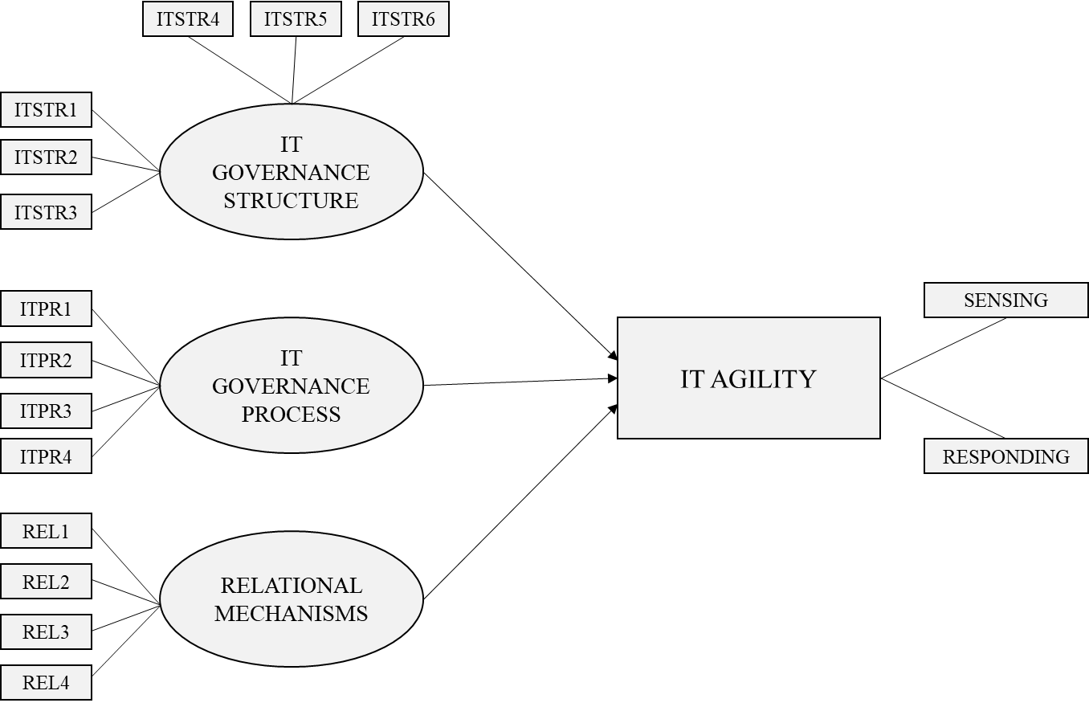

Research Model Components:
ITSTR1: Alignment of governance and tasks while designing roles & responsibilities
ITSTR2: IT Strategy Committee
ITSTR3: IT Security Steering Committee
ITSTR4: IT Steering Committee
ITSTR5: CIO on Board/Executive Committee
ITSTR6: Security / Compliance /Risk Officer
ITPR1: Strategic Information Systems Planning
ITPR2: IT governance Framework such as COBIT and ITIL
ITPR3: Business/IT Alignment Model
ITPR4: IT Performance Measurement
REL1: Cross-functional business/IT training
REL2: Top management support for business-IT collaboration
REL3: IT Leadership
REL4: Mutual comprehension of business and IT objectives

As a second step of the study, a survey has been prepared and delivered to the intended respondents, who are the IT professionals with plenty knowledge of IT governance. It was able to get 225 responds. To enrich dataset, it was targeted to get responds from IT professionals with the variety position levels, industries and company size. After statistical analysis, it is concluded that IT Governance Structure and IT Governance Process have no significant impact on IT Agility while Relational Mechanisms have a positive impact on IT Agility

Hypothesis Test Results:
Hypothesis | Results
IT Governance Structure has a positive impact on IT Agility. | Not Supported
IT Governance Process has a positive impact on IT Agility. | Not Supported
Relational Mechanisms have a positive impact on IT Agility. | Supported

Could you provide your professional opinion about the hypothesis testing results by answering questions such as “Do the results make sense to you?”, “Were the results found as you expected”? Please provide any other comments or opinion related with the results. Thank you in advance for your time, patience and the value you added to the study.

CURRICULUM VITAE

PERSONAL INFORMATION
Surname, Name: Sarı, Burçin
EDUCATION
Degree | Institution | Year of Graduation
PHD  MS | METU, INFORMATION SYSTEMS, TÜRKİYE  TEMPLE UNIVERSITY, IT AUDITING AND CYBERSECURITY, USA | Present  2013
BS | BILKENT UNIVERSITY, INDUSTRIAL ENGINEERING, TÜRKİYE | 2010
PUBLICATIONS
Journal Papers
Sarı, B. et. al. (2024) Exploring the Impact of IT Governance Mechanisms on IT Agility. Information Systems Management. (Revised Paper Submitted)

Özturan, M., Mutlutürk, M., Çeken, B., & Sarı, B. (2019). Evaluating the information systems integration maturity level of travel agencies. Information Technology & Tourism, 21(2), 237-257.

Conference Paper
Sari, B., Yildirim, S., (2024). Rethinking The Centralization of IT Governance: Voices of Seniors from a Large Technology Organization. Proceedings of the 17th IADIS International Conference, Portugal, 204(147). ISBN: 978-989-8704-56-6

WORK EXPERIENCE
Year | Company -Location | Role-Description
2023-Present | BİLKENT ÜNİVERSİTESİ-ANKARA, TÜRKİYE | INSTRUCTOR
2017-Present | ASELSAN-ANKARA, TÜRKİYE | SENIOR LEAD IT AUDITOR
2015-2017 | YAPI KREDİ BANKASI-İSTANBUL, TÜRKİYE | IT AUDITOR
2014-2015 | ERNST & YOUNG-  GREATER NEW YORK AREA, USA | CONSULTANT
2013-2014 | THE VANGUARD GROUP-MALVERN, USA | SENIOR TECHNOLOGY AUDITOR

FOREIGN LANGUAGES
Native Turkish, Advanced English

